Resource Article
Evaluating the impact of reference genome choice on SNP calling and population genomics in recently diverged species

Luana S. Soares¹, Leonardo T. Gonçalves¹, Sebastián Guzmán-Rodriguez¹, Aureliano Bombarely², Loreta B. Freitas^{1*}

¹Department of Genetics, Universidade Federal do Rio Grande do Sul, Porto Alegre, Brazil; ²Instituto de Biologia Molecular y Celular de Plantas (IBMCP) (CSIC-UPV), Valencia, Spain

* Corresponding Author: E-mail address: loreta.freitas@ufrgs.br (L. B. Freitas)

Author Orcid
Luana S. Soares - https://orcid.org/0000-0002-1893-3576
Leonardo T. Gonçalves - https://orcid.org/0000-0002-3593-8424
Sebastián Guzmán-Rodriguez - https://orcid.org/0000-0001-9860-0001
Aureliano Bombarely - https://orcid.org/0000-0001-6257-8914
Loreta B. Freitas - https://orcid.org/0000-0002-0728-4945

Running Title: Reference choice in population genomics

Abstract
The use of RAD-seq data in population genomics is strongly influenced by bioinformatic processing choices, particularly in SNP discovery and demographic inference. A key decision involves whether to adopt a de novo or reference-based approach, with the latter introducing potential biases depending on the genetic proximity between the reference genome and the focal species. While it is generally recommended to use high-quality genomes from closely related taxa, little is known about how relatedness affects evolutionary inferences, especially in systems of recent and rapid divergence. Here, we evaluate how the choice of reference genome influences SNP calling and downstream genetic analyses in recently diverged lineages of Petunia and Calibrachoa. We compare multiple reference genomes that vary in genetic distance from the target species, assessing their impact on population genetic parameters and phylogenetic relationships. Despite observing differences in absolute SNP numbers and dataset composition, our results show that overall patterns of genetic diversity, population structure, and evolutionary relationships remain consistent across references. These findings suggest that for recently diverged taxa, the choice of reference genome may be less critical than previously assumed. Genetic similarity within this evolutionary timescale appears sufficient to capture key patterns of variation and divergence, thus reducing the influence of reference selection on population and evolutionary interpretations.

Keywords: RAD-seq; rapid divergence; recent speciation; genome choice; bioinformatic approach; population genomics; reference genome.
Introduction
Recent advancements in high-throughput sequencing technologies have transformed the study of non-model organisms in ecology and evolutionary biology (Ellegren 2014; Shafer et al. 2016; 2017). One of the most significant developments has been the advent of reduced-representation sequencing methods, such as restriction-site associated DNA sequencing (RAD-seq). This approach enables the cost-effective and efficient identification of thousands of polymorphic loci across the genome without requiring a complete reference genome (Andrews et al. 2016). RAD-seq has proven particularly useful for population genetics, phylogenetics, and conservation genomics, making it an invaluable tool for researchers working with diverse taxa, including species lacking well-annotated genomes.
Despite the advantages of RAD-seq, the bioinformatics processing of the resulting data presents several challenges and potential biases. The choice between reference-based and de novo assembly approaches significantly influences SNP discovery, population genetic inferences, and evolutionary interpretations (Shafer et al. 2017). When a high-quality reference genome is available, aligning sequencing reads to this reference enhances genotype calling accuracy and facilitates analyses such as demographic history reconstruction and selection scans (Manel et al. 2015; Brandies et al. 2019). However, an appropriate reference genome is often unavailable in non-model species, leading researchers to choose a reference from a closely related species or adopt a de novo approach (Reid et al. 2021). Each strategy introduces distinct biases: reference-based approaches may suffer from mapping bias, resulting in erroneous estimates of heterozygosity and allele frequencies (Günther and Nettelblad 2019), whereas de novo assembly may lead to fragmentation and increased sequencing errors (Davey and Blaxter 2010).
The recommendation to use the "closest available reference genome" in reference-based approaches for non-model species is widely accepted (Galla et al. 2018; Therkildsen and Palumbi 2017); however, there is limited understanding of how closely related the reference should be. The "closeness" is often ambiguous and varies across systems with different evolutionary histories. The impact of reference genome selection remains unclear in species that have diverged relatively recently and rapidly.
The genera Petunia Juss. and Calibrachoa Cerv., both members of the Solanaceae family, provide an excellent system for investigating this question. Petunia is a genus better known for its cultivated P. x hybrida (Hook.) Vilm. and includes 20 wild species with recent and rapid divergence (e.g., Särkinen et al. 2013; Reck-Kortmann et al. 2014; Backes et al. 2024; Soares et al. 2025). Similarly, Calibrachoa, a close relative of Petunia (Särkinen et al. 2013; Pezzi et al. 2024), consists of species that also exhibit rapid evolutionary divergence (Fregonezi et al. 2012; Mäder and Freitas 2019; Backes et al., unpublished data). However, no congeneric reference genome is currently available for Calibrachoa, necessitating reference genomes from related taxa.
In this study, we explicitly evaluate how the choice of reference genome influences SNP calling and downstream evolutionary interpretations in Petunia and Calibrachoa. Specifically, we compare the performance of multiple reference genomes that differ in genetic proximity to our target species to assess how the selection of the reference genome impacts key population and phylogenetic analyses. We hypothesized that increased phylogenetic distance between the reference and focal genomes would reduce mapping quality and SNP calling accuracy, potentially leading to biases in population genetic inference. Additionally, we tested whether and how low coverage biases the inference of population genetic statistics. In this regard, we hypothesized that low coverage sequencing might not directly impact the main statistics of a population genetics study, namely nucleotide diversity (π), inbreeding coefficient (F_{IS}), or the percentage of polymorphisms. This indicates that even at a low coverage rate, sequencing experiments involving multiple populations may yield true and valuable information about a species.
By addressing these questions, we provided insights into best practices for conducting genomic analyses of recently and rapidly diverging species. We improved the broader understanding of reference genome selection in population genomics. Instead of focusing on the absolute variation in number between the assemblies, we emphasized whether the evolutionary interpretation of the data would differ across various tests.

Materials and Methods
Study Design and Dataset Overview
To evaluate the impact of reference genome selection on SNP calling and downstream population and phylogenetic inference, we used raw sequencing data from previously published studies, comprising 121 individuals from Petunia species (Soares and Freitas, 2024; Soares et al., 2024, 2025) and 40 individuals from the closely related genus Calibrachoa (Backes et al., unpublished data). We structured our analysis around three datasets representing increasing levels of phylogenetic divergence from the available reference genomes: 1) POP (population-level dataset): 80 individuals from three populations of the single species Petunia altiplana, used to assess the effects of reference choice within populations; 2) INTRA-P4 (intraspecific dataset): 41 individuals representing four recently diverged Petunia species, used to test genome reference choice within the same genus; 3) INTER-C5 (interspecific dataset): 40 individuals from five Calibrachoa species to examine the effect of using more distantly related references. We tested each dataset against six reference genomes that span a gradient of phylogenetic distances: 1) Closely related: Petunia inflata and P. axillaris I (Bombarely et al. 2016) and P. axillaris II and P. secreta available at the National Center for Biotechnology Information (NCBI; https://www.ncbi.nlm.nih.gov/); 2) Distantly related groups: Nicotiana sylvestris (Sierro et al. 2024) and Solanum habrochaites (Yu et al. 2022).
The Petunia species are grouped into two clades based on corolla tube length (short and long), with a divergence time estimated at approximately 2.85 Mya (Särkinen et al. 2013). The POP and INTRA-P4 datasets included only species with short corolla tubes, which diverged around 2 Mya (Soares et al. 2025). Among the reference genomes, P. inflata, a species with a short corolla tube, is the closest related species to these datasets. Petunia axillaris and P. secreta genomes represent the long corolla tube clade.
The Calibrachoa species included in the INTER-C5 dataset diverged from Petunia approximately 8.5 million years ago (Mya; Särkinen et al. 2013), and we mapped it to the four Petunia genomes to test the effects of greater divergence. Additionally, we included two more distant reference genomes—Nicotiana L. and Solanum L.— whose lineages diverged from the Petunia-Calibrachoa clade around 27 Mya and from each other approximately 24 Mya (Särkinen et al. 2013).
We summarized the evolutionary relationships among the studied species and reference genomes presented in Figure 1. Such data were obtained from the literature (Särkinen et al. 2013; Soares et al. 2025) and TimeTree (Kumar et al 2017).
The article design allowed us to systematically test the hypothesis of whether mapping quality, SNP discovery, and downstream population and evolutionary inferences decrease as the phylogenetic distance between the dataset and the reference genome increases.

Does the Number of Reads Matter?
To evaluate the impact of mapping quality and sequencing depth on population genetic statistics, we simulated low-coverage sequencing by randomly subsampling reads from each sample. We used the POP and INTRA-P4 sequences to conduct this analysis and the custom Python and Bash scripts to generate subsampled datasets. We tested 50,000, 100,000, 200,000, and up to 500,000 reads per sample to reflect realistic genome coverage variation. Each subsampling scheme was replicated ten times to account for the stochastic variation introduced by the random sampling process. We mapped each subsampled dataset to the P. axillaris I genome. This approach allowed us to assess the robustness of downstream genetic analyses across a range of sequencing depths and to identify potential biases associated with low-coverage data. Each subsampled dataset was then assessed using population genetics statistics such as the number of private alleles, nucleotide diversity (π), observed heterozygosity (Ho), and inbreeding coefficient (F_{IS}).

SNP Calling and Filtering
The workflow of the analyses is graphically explained in Figure 2. All sequence groups were processed identically for SNP calling. Raw reads were inspected using FASTQC v0.11.7 (Andrews 2010) and MULTIQC (Ewels et al. 2016). Adapters and barcodes were removed, low-quality regions (< Q30) were trimmed, and reads <50 bp were discarded with FASTQ-MCF v1.04.807 (Aronesty 2013). Filtered reads were mapped against all reference genomes.
With default settings, the mapping utilized BWA v0.7.10-r789 (Li and Durbin 2010). Unmapped reads were discarded, and BAM files were processed using SAMTOOLS v1.3.1 (Danecek et al. 2021). BAM files were merged per reference genome with bamaddrg (https://github.com/ekg/bamaddrg), sorted, and indexed with SAMTOOLS. Variants were called with FREEBAYES v1.3.6 (Garrison and Marth 2012) using mapping quality >30, base quality > 30, and read depth >10. Filtering thresholds varied by dataset. For the population-level group, SNPs with 5–50% missing data and minor allele frequency (--maf) ≥ 0.05 were included. Linkage disequilibrium (LD) was minimized by retaining only one SNP at each 100 bp (--thin) using VCFTOOLS v0.1.12 (Danecek et al. 2011). We assessed the mapping rate (the proportion of total reads from each sample successfully mapped to the reference genome) and the number of SNPs recovered in each data group.
Additionally, we evaluated the impact of missing data on diversity indices, including the number of private alleles, nucleotide diversity, observed heterozygosity, and inbreeding coefficient, using the POP and INTRA-P4 datasets. The same 5-50% range was considered.

Genetic Diversity, Population Differentiation, and Phylogeny
We processed each data group separately and conducted a basic standard population genetics analysis to understand genetic diversity, structure, and phylogenetic relationships. We used the filtered datasets, which excluded monomorphic sites (variants that appeared in just one individual when compared with the reference genome), to estimate genetic diversity indices such as nucleotide diversity (π, calculated per site), private alleles, polymorphic site proportion (P), observed (Ho) and expected (He) heterozygosity, and inbreeding coefficients (F_{IS}) using STACKS v2.41 (Rivera-Colón and Catchen 2022). Finally, we performed a principal components analysis (PCA) using the gl.pcoa function in DARTR (Mijangos et al 2022).
Population and species structure were inferred using fastSTRUCTURE v1.074 (Raj et al. 2014). We ran K values from 1 to 15 with 10 repetitions per run. The STRUCTURE_THREADER software (Pina-Martins et al. 2017) was utilized, and the results were summarized using STRUCTURE HARVESTER (Earl and von Holdt 2012). The most likely number of clusters was evaluated by inspecting likelihood plots and applying Evanno’s method (Evanno et al. 2005). We employed POPHELPER (Francis 2017) to plot the graphs, organizing them primarily to maintain a consistent color pattern in the GRAPHIC software. Finally, we estimated the pairwise fixation index (F_{ST}) using ARLEQUIN v3.5.2.2 (Excoffier and Lischer 2010).
We used the NeighborNet method in SPLITSTREE v4.16 (Huson and Bryant 2006) to build a network of relationships among individuals in each dataset and examine their evolutionary connections. We plotted and compared the results from all datasets to determine whether the choice of genome reference affects the primary evolutionary interpretation of the data.

Results
Number of Reads per Individual
Across the subsampled datasets, we observed variation in the absolute values of genetic diversity indices. Lower read counts generally led to reduced estimates of genetic diversity and greater variance among replicates. However, despite these quantitative differences, the overall patterns and relative comparisons among populations remained consistent across the different subsampling schemes (Figure S1). These results suggest that while sequencing depth affects the precision of diversity estimates, the overall interpretation of population structure and diversity patterns is resilient to moderate reductions in genome coverage.

Mapping Rates
The mapping rates were positively correlated with the phylogenetic proximity between the dataset and the reference genome (Figure 3). In the Petunia datasets (POP and INTRA-P4), the mapping rates were similar for P. axillaris I, P. axillaris II, and P. secreta genomes, while mapping against the P. inflata genome resulted in a slightly higher average (Table 1). When referencing Nicotiana and Solanum, mapping rates were lower, with N. sylvestris exhibiting higher rates than S. habrochaites. INTER-C5 displayed lower values when using Petunia genomes as a reference compared to POP and INTRA-P4, whereas it demonstrated slightly higher rates when employing Nicotiana and Solanum reference genomes.

SNP Discovery
After mapping, SNP calling, and filtering, we generated 72 VCF files across three datasets and six reference genomes. We applied a range of missing data thresholds for each dataset, from 50% to 5%. The number of retained SNPs decreased as the stringency of the missing data threshold increased (Figure S2). However, the total number of SNPs recovered was consistent across the four Petunia reference genomes. P. inflata yielded slightly more SNPs for the POP dataset than any other Petunia genomes. However, we did not observe the same pattern for the INTRA-P4 and INTER-C5 datasets, where there was no clear relationship between SNP count and evolutionary proximity. In contrast, when considering the more distantly related groups (N. sylvestris and S. habrochaites), the number of SNPs dropped substantially, falling five to seven-fold fewer.
Different levels of missing data influenced the estimates of genetic diversity (Figure S3). The amount of missing data was the most significant factor affecting the differences across all population groups. In particular, higher levels of missing data correlated with more private alleles, lower π and Ho values, and higher inbreeding coefficients. Different Petunia reference genomes did not impact the diversity estimates. Conversely, the genomes of N. sylvestris and S. habrochaites exhibited significantly different statistics. The same patterns were observed across the three datasets.

Population Structure and Evolutionary Relationships
We assessed the population structure and evolutionary relationships for each VCF file. Despite the varying reference genomes and differences in SNP counts, the overall results were highly congruent across all analyses. We focused on the results from a 10% missing data threshold, a commonly applied standard in the literature. Complete results for other thresholds are available in the Supplementary Information.
PCA results were consistent across reference genomes (Figure 4). Although each principal component (PC) axis varied slightly in explaining the percentage of variance, the relative positions of individuals and clusters remained stable throughout the analyses. This finding indicates that population structure and evolutionary patterns were robust, regardless of the reference genome utilized.
F_{ST} values were also consistent across reference genomes (Table 1), showing no significant variation based on the reference. The overall pattern of population differentiation and the relative relationships among groups remained stable. This result suggests that the biological interpretation is unaffected, while the reference genome might influence the magnitude of F_{ST}.
fastSTRUCTURE results followed similar trends, although there was slightly more variation across reference genomes. As is typical with this method, no single best K was inferred. Instead, the analysis returned a range of plausible K values (Table S2). The datasets mapped to the Solanum reference genome exhibited the most significant variation in the inferred K values, particularly within the POP and INTRA-P4 datasets. We selected the best K based on previous studies for each dataset to explore.
For POP (Figure 5a), we selected K = 3, which reflects three geographical groups in P. altiplana. Most of the reference genomes returned identical results, except when using the P. secreta genome, which indicated different ancestry for many individuals. The best K = 5 for INTRA-P4 (Figure 5b) revealed intraspecific structure in two lineages, while others remained undifferentiated, as expected from the evolutionary history of the dataset (Soares et al., unpublished data). Overall, the reference genomes produced consistent ancestry patterns. For the INTER-C5 dataset (Figure 5c), corresponding to the number of species, the population structure was largely consistent, with each species displaying a distinct genetic component. However, for two taxa, ancestry assignments varied depending on the reference genome, with greater discrepancies observed when using the Nicotiana and Solanum genomes.
SPLITSTREE analyses (Figure 6) showed consistent topologies across reference genomes. Using the Nicotiana and Solanum genomes resulted in trees with broader internal nodes, likely due to the reduced number of SNPs. Nevertheless, the general relationships among individuals and groups remained consistent.

Discussion
The emergence of next-generation sequencing (NGS) methodologies, particularly those based on RAD-seq, has integrated ecology, evolution, and conservation research across a diverse range of species. These methodologies enable the inclusion of hundreds to thousands of genetic polymorphisms throughout the entire genome. Key advantages over other methods include improved cost-effectiveness and greater depth of coverage per locus (Andrews et al. 2016). The RAD-seq approaches utilize NGS to generate sequences adjacent to restriction cut sites in coding and non-coding genomic regions, which are shared within or between closely related species (Cariou et al. 2013).
Despite the care and advancements in the initial stages of analyses involving RAD-seq-derived polymorphisms, several phenomena can significantly affect subsequent analyses, including the number of reads, the proportion of missing data, and the genome used as a reference for variant calling. In this study, we tested the impact of these phenomena on estimates of genetic diversity, population structure, and evolutionary relationships in closely related and rapidly diversified plant lineages. We used DArT-derived SNPs from multiple individuals of the genus Petunia and some related species as a model for this. We compared the effects of mapping them against closely and distantly positioned reference genomes.

The More the Better?
The RAD-seq for evolutionary studies evaluates genomic DNA from multiple samples of interest, making it a population-scale sequencing method. Due to various technical factors, the number of reads may differ, leading to varying genome coverage among samples. It is known that loci with missing haplotypes can have estimated summary statistic values that deviate dramatically from true values (Arnold et al. 2013). Given the elevated error rates inherent to NGS compared to conventional Sanger sequencing, a standard quality control measure involves implementing a minimum read depth threshold to ensure accurate genotype calling at specific loci. Sequencing libraries with lower coverage inherently yield reduced data matrix dimensions due to a higher incidence of loci failing to meet coverage requirements for a fixed threshold of allowable missing data. However, such outcomes should not be interpreted as prescriptive evidence favoring higher over lower coverage (Huang and Knowles 2016).
Here we observed that even with one-tenth of the number of reads, we recover the same trend (Figure 3) regarding intraspecific lineages (POP) or closely related species (INTRA-P4) despite variations in absolute values. Only private alleles changed in the POP comparison, while the inbreeding coefficient, observed heterozygosity, and nucleotide diversity maintained the pattern. These results indicate that reliable genetic and evolutionary inferences can still be drawn from these recently diverged lineages, even with relatively low-coverage datasets.

Missing Data
RAD-Seq generates tens of thousands of loci per individual; however, the number of overlapping loci across all individuals is much lower, leading to significant missing data. Since missing data can impact the estimation of diversity indices and the inference of population structure or evolutionary relationships, it is crucial to test its effect on the analyses (Chatttopadhyay et al. 2014). While missing data may not significantly impact phylogenetic inference (Hovmöller et al. 2013), other forms of population genetic inference can be affected.
Our results indicated that even with 50% of the data missing, the trends in estimating the diversity indices, population structure, and phylogenetic relationships are preserved, despite differences in nominal values and a greater impact on private allele numbers. The reference genome did not affect these estimates or patterns (Figures S2, S3).

Reference Genome Choice
The alignment of reads to a reference genome fundamentally depends on sequence homology (Davey et al. 2011), with reads harboring elevated mutation rates or high sequence variability typically showing reduced alignment scores (Nielsen et al. 2011; Huang and Knowles 2016). Consequently, the phylogenetic proximity of the reference genome can significantly influence alignment efficiency and downstream analytical outcomes.
Alignments to more distantly related reference genomes generally yield a higher proportion of low-scoring reads, while alignments to closely related genomes preferentially retain conserved regions with lower mutation rates post-filtering (McCormack et al. 2009; Huang and Knowles 2016). Additionally, DNA fragments that contain alleles identical to the reference sequence are more likely to map successfully and meet post-alignment quality thresholds, leading to their overrepresentation in subsequent analyses (Brandt et al. 2015; Ros-Freixedes et al. 2018). This reference bias becomes increasingly pronounced with evolutionary divergence, particularly in highly polymorphic genomic regions. This pattern explains why the Petunia datasets (POP and INTRA-P4) exhibited the highest mapping rates overall when using Petunia reference genomes, with the genome from the closest species within the same clade (P. inflata) yielding the highest rates among all references.
Empirical and simulation-based studies have demonstrated that the choice of reference genome can introduce systematic biases in population genomic inferences, including estimates of demographic history, heterozygosity, and runs of homozygosity (e.g., Shafer et al. 2017; Günther and Nettelblad 2019; Prasad et al. 2021; Reid et al. 2021). In phylogenetic contexts, divergent reference genomes have been shown to reduce heterozygote call accuracy (Duchen and Salamin 2021). However, in the young lineages of Petunia, particularly in the POP and INTRA-P4 comparisons, we observed that there are no significant differences in structure and phylogenetic patterns, and diversity estimates remain relatively constant, despite the evolutionary distance between the target and reference genomes. This finding contradicted our initial hypothesis.
Missing data thresholds tend to improve topological accuracy; however, this may narrow the mutational spectrum, potentially offsetting the benefits of reduced noise. These findings build upon and expand the scope of previous investigations, most of which focused on isolated filtering and alignment parameters (e.g., Lanier et al. 2014; Huang and Knowles 2016; Shafer et al. 2017; Molloy and Warnow 2018; Günther and Nettelblad 2019; Linck and Battey 2019; Prasad et al. 2021), demonstrating that reference genome choice can compound or modulate the effects of specific filtering strategies. Importantly, many of these impacts persist independently of the absolute size of the final dataset, underscoring that the composition and characteristics of retained data, rather than data volume alone, drive biases in phylogenetic inference. We observed that increasing the evolutionary distance between the reference genome and the target taxa was associated with broader internal nodes in the inferred trees (Figure 6). However, reference genome divergence alone did not significantly predict topological imbalance in our focal comparisons.
It is also plausible that genome assembly quality, beyond evolutionary relatedness, modulates the retention of phylogenetic signals. For instance, highly contiguous assemblies may preserve more SNPs, while fragmented genomes may inadvertently retain greater sequence diversity. This trade-off is common when researchers choose between a high-quality but phylogenetically distant genome and a closely related yet fragmented assembly. Therefore, some of the divergence-related effects observed in our empirical results—and potential inconsistencies with simulation outcomes—may be attributable to differences in assembly completeness. While genome assembly quality does not appear to bias demographic inferences in population genomics (Patton et al. 2019), its influence on phylogenetic reconstruction remains uncertain. Here, we included reference genomes with diverse quality and chromosome coverage and did not observe a significant difference in population structure or evolutionary relationship patterns across the focal groups (Figures 4, 5, 6).
A widely recommended best practice is to align reads to the closest available reference genome. However, the operational definition of "closeness" is context-dependent and varies with the evolutionary history and dynamics of the study system (Rick et al. 2024). In our study, we explicitly incorporated a range of divergence levels, from less than 1 million years (e.g., analyses of POP and INTRA-P4 using the Petunia inflata genome) to more than 20 million years (e.g., alignments involving Nicotiana and Solanum references). Despite nominal value differences, overall patterns of evolutionary relationships and population structure were largely preserved across scenarios (see Figures 4, 5, 6).
In conclusion, our results showed that, despite observing some absolute differences in SNP datasets, the overall interpretation of genetic diversity, population structure, and evolutionary relationships remains consistent across reference genomes. The findings indicated that for recently diverged species, selecting a reference genome may not be as crucial as previously thought. Genetic similarities between the focal and reference genomes are sufficient to provide appropriate population and evolutionary information, reducing the importance of reference choice for these species.

Acknowledgements
The authors thank Dr. João R. Stehmann (Universidade Federal de Minas Gerais, Brazil) for plant identification.

Funding
This work was supported by CNPq (Conselho Nacional de Desenvolvimento Científico e Tecnológico), CAPES (Fundação Coordenação de Aperfeiçoamento de Pessoal de Nível Superior), FAPERGS (Fundação de Amparo à Pesquisa do Estado do Rio Grande do Sul), and PPGBM-UFRGS (Programa de Pós-Graduação em Genética e Biologia Molecular, Universidade Federal do Rio Grande do Sul). LSS was supported by a CAPES/PRINT fellowship and a Ph.D. CNPq scholarship.

References
Andrews, K. R., Good, J. M., Miller, M. R., Luikart, G., & Hohenlohe, P. A. (2016). Harnessing the power of RADseq for ecological and evolutionary genomics. Nature Reviews Genetics 2016 17:2, 17(2), 81–92. https://doi.org/10.1038/nrg.2015.28
Andrews, S. (2010). FastQC:A Quality Control Tool for High Throughput Sequence Data [Online].
Arnold, B., Corbett‐Detig, R. B., Hartl, D., & Bomblies, K. (2013). <scp>RAD</scp> seq underestimates diversity and introduces genealogical biases due to nonrandom haplotype sampling. Molecular Ecology, 22(11), 3179–3190. https://doi.org/10.1111/mec.12276
Aronesty, E. (2013). Comparison of Sequencing Utility Programs. The Open Bioinformatics Journal, 7(1), 1–8. https://doi.org/10.2174/1875036201307010001
Backes, A., Turchetto, C., Mäder, G., Segatto, A. L. A., Bonatto, S. L., & Freitas, L. B. (2024). Shades of white: The Petunia long corolla tube clade evolutionary history. Genetics and Molecular Biology, 47(1). https://doi.org/10.1590/1415-4757-gmb-2023-0279
Bombarely, A., Moser, M., Amrad, A., Bao, M., Bapaume, L., Barry, C. S., Bliek, M., Boersma, M. R., Borghi, L., Bruggmann, R., Bucher, M., D’Agostino, N., Davies, K., Druege, U., Dudareva, N., Egea-Cortines, M., Delledonne, M., Fernandez-Pozo, N., Franken, P., … Kuhlemeier, C. (2016). Insight into the evolution of the Solanaceae from the parental genomes of Petunia hybrida. Nature Plants, 2, 16074. https://doi.org/10.1038/nplants.2016.74
Brandies, P., Peel, E., Hogg, C. J., & Belov, K. (2019). The Value of Reference Genomes in the Conservation of Threatened Species. Genes, 10(11), 846. https://doi.org/10.3390/genes10110846
Brandt, D. Y. C., Aguiar, V. R. C., Bitarello, B. D., Nunes, K., Goudet, J., & Meyer, D. (2015). Mapping bias overestimates reference allele frequencies at the HLA genes in the 1000 genomes project phase I data. G3: Genes, Genomes, Genetics, 5(5), 931–941. https://doi.org/10.1534/G3.114.015784/-/DC1
Cariou, M., Duret, L., & Charlat, S. (2013). Is RAD‐seq suitable for phylogenetic inference? An in silico assessment and optimization. Ecology and Evolution, 3(4), 846–852. https://doi.org/10.1002/ece3.512
Chattopadhyay, B., Garg, K. M., & Ramakrishnan, U. (2014). Effect of diversity and missing data on genetic assignment with RAD-Seq markers. BMC Research Notes, 7(1), 841. https://doi.org/10.1186/1756-0500-7-841
Danecek, P., Auton, A., Abecasis, G., Albers, C. A., Banks, E., DePristo, M. A., Handsaker, R. E., Lunter, G., Marth, G. T., Sherry, S. T., McVean, G., & Durbin, R. (2011). The variant call format and VCFtools. Bioinformatics, 27(15), 2156–2158. https://doi.org/10.1093/bioinformatics/btr330
Danecek, P., Bonfield, J. K., Liddle, J., Marshall, J., Ohan, V., Pollard, M. O., Whitwham, A., Keane, T., McCarthy, S. A., Davies, R. M., & Li, H. (2021). Twelve years of SAMtools and BCFtools. GigaScience, 10(2). https://doi.org/10.1093/gigascience/giab008
Davey, J. L., & Blaxter, M. W. (2010). RADSeq: next-generation population genetics. Briefings in Functional Genomics, 9(5–6), 416–423. https://doi.org/10.1093/BFGP/ELQ031
Davey, J. W., Hohenlohe, P. A., Etter, P. D., Boone, J. Q., Catchen, J. M., & Blaxter, M. L. (2011). Genome-wide genetic marker discovery and genotyping using next-generation sequencing. Nature Reviews Genetics, 12(7), 499–510. https://doi.org/10.1038/nrg3012
Duchen, P., & Salamin, N. (2021). A Cautionary Note on the Use of Genotype Callers in Phylogenomics. Systematic Biology, 70(4), 844–854. https://doi.org/10.1093/sysbio/syaa081
Earl, D. A., & vonHoldt, B. M. (2012). STRUCTURE HARVESTER: a website and program for visualizing STRUCTURE output and implementing the Evanno method. Conservation Genetics Resources, 4(2), 359–361. https://doi.org/10.1007/s12686-011-9548-7
Ellegren, H. (2014). Genome sequencing and population genomics in non-model organisms. Trends in Ecology & Evolution, 29(1), 51–63. https://doi.org/10.1016/J.TREE.2013.09.008
EVANNO, G., REGNAUT, S., & GOUDET, J. (2005). Detecting the number of clusters of individuals using the software Structure: a simulation study. Molecular Ecology, 14(8), 2611–2620. https://doi.org/10.1111/j.1365-294X.2005.02553.x
Ewels, P., Magnusson, M., Lundin, S., & Käller, M. (2016). MultiQC: summarize analysis results for multiple tools and samples in a single report. Bioinformatics, 32(19), 3047–3048. https://doi.org/10.1093/bioinformatics/btw354
Excoffier, L., & Lischer, H. E. L. (2010). Arlequin suite ver 3.5: a new series of programs to perform population genetics analyses under Linux and Windows. Molecular Ecology Resources, 10(3), 564–567. https://doi.org/10.1111/J.1755-0998.2010.02847.X
Francis, R. M. (2017). pophelper: an R package and web app to analyze and visualize population structure. Molecular Ecology Resources, 17(1), 27–32. https://doi.org/10.1111/1755-0998.12509
Fregonezi, J. N., de Freitas, L. B., Bonatto, S. L., Semir, J., & Stehmann, J. R. (2012). Infrageneric classification of Calibrachoa (Solanaceae) based on morphological and molecular evidence. TAXON, 61(1), 120–130. https://doi.org/10.1002/tax.611009
Galla, S. J., Forsdick, N. J., Brown, L., Hoeppner, M. P., Knapp, M., Maloney, R. F., Moraga, R., Santure, A. W., & Steeves, T. E. (2018). Reference genomes from distantly related species can be used for discovery of single-nucleotide polymorphisms to inform conservation management. Genes 10(1), 9. https://doi.org/10.3390/GENES10010009
Garrison, E., & Marth, G. (2012). Haplotype-based variant detection from short-read sequencing. http://arxiv.org/abs/1207.3907
Günther, T., & Nettelblad, C. (2019). The presence and impact of reference bias on population genomic studies of prehistoric human populations. PLOS Genetics, 15(7), e1008302. https://doi.org/10.1371/JOURNAL.PGEN.1008302
Hovmöller, R., Lacey Knowles, L., & Kubatko, L. S. (2013). Effects of missing data on species tree estimation under the coalescent. Molecular Phylogenetics and Evolution, 69(3), 1057–1062. https://doi.org/10.1016/j.ympev.2013.06.004
Huang, H., & Knowles, L. L. (2016). Unforeseen Consequences of Excluding Missing Data from Next-Generation Sequences: Simulation Study of RAD Sequences. Systematic Biology, 65(3), 357–365. https://doi.org/10.1093/sysbio/syu046
Huson, D. H., & Bryant, D. (2006). Application of Phylogenetic Networks in Evolutionary Studies. Molecular Biology and Evolution, 23(2), 254–267. https://doi.org/10.1093/MOLBEV/MSJ030
Kumar, S., Stecher, G., Suleski, M., & Hedges, S. B. (2017). TimeTree: A Resource for Timelines, Timetrees, and Divergence Times. Molecular Biology and Evolution, 34(7), 1812–1819. https://doi.org/10.1093/molbev/msx116
Lanier, H. C., Huang, H., & Knowles, L. L. (2014). How low can you go? The effects of mutation rate on the accuracy of species-tree estimation. Molecular Phylogenetics and Evolution, 70, 112–119. https://doi.org/10.1016/j.ympev.2013.09.006
Li, H., & Durbin, R. (2010). Fast and accurate long-read alignment with Burrows–Wheeler transform. Bioinformatics, 26(5), 589–595. https://doi.org/10.1093/bioinformatics/btp698
Linck, E., & Battey, C. J. (2019). Minor allele frequency thresholds strongly affect population structure inference with genomic data sets. Molecular Ecology Resources, 19(3), 639–647. https://doi.org/10.1111/1755-0998.12995
Mäder, G., & Freitas, L. B. (2019). Biogeographical, ecological, and phylogenetic analyses clarifying the evolutionary history of Calibrachoa in South American grasslands. Molecular Phylogenetics and Evolution, 141, 106614. https://doi.org/10.1016/j.ympev.2019.106614
Manel, S., Perrier, C., Pratlong, M., Abi‐Rached, L., Paganini, J., Pontarotti, P., & Aurelle, D. (2016). Genomic resources and their influence on the detection of the signal of positive selection in genome scans. Molecular Ecology, 25(1), 170–184. https://doi.org/10.1111/mec.13468
Mijangos, J. L., Gruber, B., Berry, O., Pacioni, C., & Georges, A. (2022). <scp> dartR </scp> v2: An accessible genetic analysis platform for conservation, ecology and agriculture. Methods in Ecology and Evolution, 13(10), 2150–2158. https://doi.org/10.1111/2041-210X.13918
Molloy, E. K., & Warnow, T. (2018). To Include or Not to Include: The Impact of Gene Filtering on Species Tree Estimation Methods. Systematic Biology, 67(2), 285–303. https://doi.org/10.1093/sysbio/syx077
Nielsen, R., Paul, J. S., Albrechtsen, A., & Song, Y. S. (2011). Genotype and SNP calling from next-generation sequencing data. Nature Reviews Genetics, 12(6), 443–451. https://doi.org/10.1038/nrg2986
Patton, A. H., Margres, M. J., Stahlke, A. R., Hendricks, S., Lewallen, K., Hamede, R. K., Ruiz-Aravena, M., Ryder, O., McCallum, H. I., Jones, M. E., Hohenlohe, P. A., & Storfer, A. (2019). Contemporary Demographic Reconstruction Methods Are Robust to Genome Assembly Quality: A Case Study in Tasmanian Devils. Molecular Biology and Evolution, 36(12), 2906–2921. https://doi.org/10.1093/molbev/msz191
Pezzi, P. H., Wheeler, L. C., Freitas, L. B., & Smith, S. D. (2024). Incomplete lineage sorting and hybridization underlie tree discordance in Petunia and related genera (Petunieae, Solanaceae). Molecular Phylogenetics and Evolution, 198, 108136. https://doi.org/10.1016/j.ympev.2024.108136
Pina-Martins, F., Silva, D. N., Fino, J., & Paulo, O. S. (2017). Structure_threader : An improved method for automation and parallelization of programs Structure, fastStructure and MavericK on multicore CPU systems. Molecular Ecology Resources, 17(6), e268–e274. https://doi.org/10.1111/1755-0998.12702
Prasad, A. B., Allard, M. W., & Green, E. D. (2008). Confirming the phylogeny of mammals by use of large comparative sequence data sets. Molecular Biology and Evolution, 25(9), 1795–1808. https://doi.org/10.1093/molbev/msn104
Prasad, A., Lorenzen, E. D., & Westbury, M. V. (2022). Evaluating the role of reference‐genome phylogenetic distance on evolutionary inference. Molecular Ecology Resources, 22(1), 45–55. https://doi.org/10.1111/1755-0998.13457
Raj, A., Stephens, M., & Pritchard, J. K. (2014). FastSTRUCTURE: Variational inference of population structure in large SNP data sets. Genetics, 197(2), 573–589. https://doi.org/10.1534/GENETICS.114.164350/-/DC1
Reck-Kortmann, M., Silva-Arias, G. A., Segatto, A. L. A., Mäder, G., Bonatto, S. L., & de Freitas, L. B. (2014). Multilocus phylogeny reconstruction: New insights into the evolutionary history of the genus Petunia. Molecular Phylogenetics and Evolution, 81, 19–28. https://doi.org/10.1016/j.ympev.2014.08.022
Reid, B. N., Moran, R. L., Kopack, C. J., & Fitzpatrick, S. W. (2021). Rapture‐ready darters: Choice of reference genome and genotyping method (whole‐genome or sequence capture) influence population genomic inference in Etheostoma. Molecular Ecology Resources, 21(2), 404–420. https://doi.org/10.1111/1755-0998.13275
Rivera-Colón, A. G., & Catchen, J. (2022). Population Genomics Analysis with RAD, Reprised: Stacks 2 (pp. 99–149). https://doi.org/10.1007/978-1-0716-2313-8_7
Ros-Freixedes, R., Battagin, M., Johnsson, M., Gorjanc, G., Mileham, A. J., Rounsley, S. D., & Hickey, J. M. (2018). Impact of index hopping and bias towards the reference allele on accuracy of genotype calls from low-coverage sequencing. Genetics Selection Evolution, 50(1), 64. https://doi.org/10.1186/s12711-018-0436-4
Särkinen, T., Bohs, L., Olmstead, R. G., & Knapp, S. (2013). A phylogenetic framework for evolutionary study of the nightshades (Solanaceae): a dated 1000-tip tree. BMC Evolutionary Biology, 13(1), 214. https://doi.org/10.1186/1471-2148-13-214
Shafer, A. B. A., Northrup, J. M., Wikelski, M., Wittemyer, G., & Wolf, J. B. W. (2016). Forecasting ecological genomics: high-tech animal instrumentation meets high-throughput sequencing. PLOS Biology, 14(1), e1002350. https://doi.org/10.1371/JOURNAL.PBIO.1002350
Shafer, A. B. A., Peart, C. R., Tusso, S., Maayan, I., Brelsford, A., Wheat, C. W., & Wolf, J. B. W. (2017). Bioinformatic processing of RAD-seq data dramatically impacts downstream population genetic inference. Methods in Ecology and Evolution, 8(8), 907–917. https://doi.org/10.1111/2041-210X.12700
Sierro, N., Auberson, M., Dulize, R., & Ivanov, N. V. (2024). Chromosome-level genome assemblies of Nicotiana tabacum, Nicotiana sylvestris, and Nicotiana tomentosiformis. Scientific Data, 11(1), 135. https://doi.org/10.1038/s41597-024-02965-2
Soares, L. S., Bombarely, A., & Freitas, L. B. (2024). How many species are there? Lineage diversification and hidden speciation in Solanaceae from highland grasslands in southern South America. Annals of Botany, 134(7), 1291–1305. https://doi.org/10.1093/aob/mcae144
Soares, L. S., & Freitas, L. B. (2024). The phylogeographic journey of a plant species from lowland to highlands during the Pleistocene. Scientific Reports, 14(1), 3825. https://doi.org/10.1038/s41598-024-53414-4
Soares L. S., Stehmann J.R., Freitas L. B.2025. The genus Petunia (Solanaceae): Evolutionary synthesis and taxonomic review. Plants. In press
Therkildsen, N. O., & Palumbi, S. R. (2017). Practical low-coverage genome-wide sequencing of hundreds of individually barcoded samples for population and evolutionary genomics in non-model species. Molecular Ecology Resources, 17(2), 194–208. https://doi.org/10.1111/1755-0998.12593
Yu, X., Qu, M., Shi, Y., Hao, C., Guo, S., Fei, Z., & Gao, L. (2022). Chromosome-scale genome assemblies of wild tomato relatives Solanum habrochaites and Solanum galapagense reveal structural variants associated with stress tolerance and terpene biosynthesis. Horticulture Research, 9. https://doi.org/10.1093/hr/uhac139

Data Accessibility
Raw sequence reads are deposited in the xxx (Project XXX). The VCF files are available at XXX

Benefit-Sharing
Benefits Generated: Benefits from this research accrue from the sharing of our data and results on public databases as described above.

Author Contributions
LBF and LSS designed the research, LSS, LTG, and SG-R analyzed data, LBF and AB contributed analytical tools, LSS and LBF wrote the paper, and all authors read and approved the manuscript.

Conflict of Interest
The authors declare that they have no competing interests.

Tables and Figures

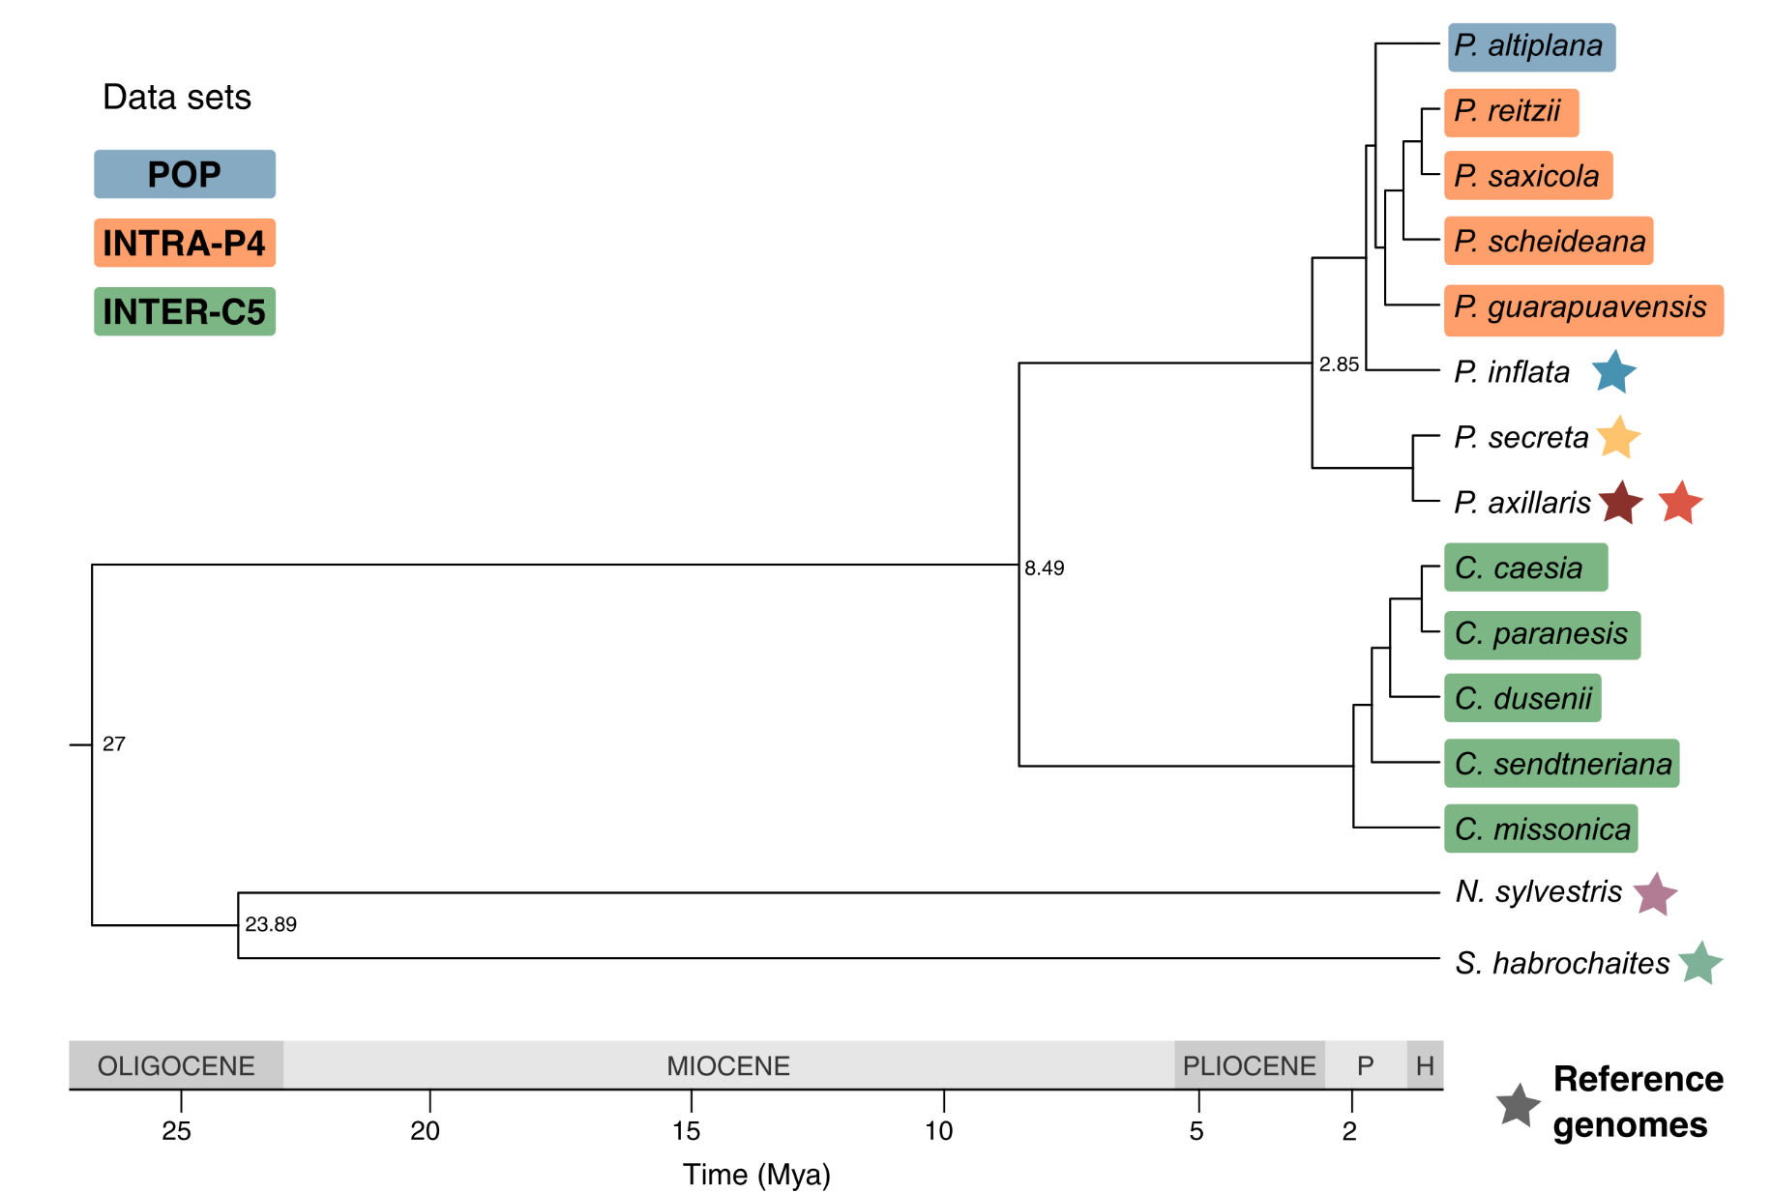
Figure 1 - Phylogenetic tree summarizing the evolutionary relationships among the studied species and reference genomes. Divergence times were obtained from published phylogenies (Särkinen et al. 2013; Soares et al. 2025) and the TimeTree database (Kumar et al. 2017).
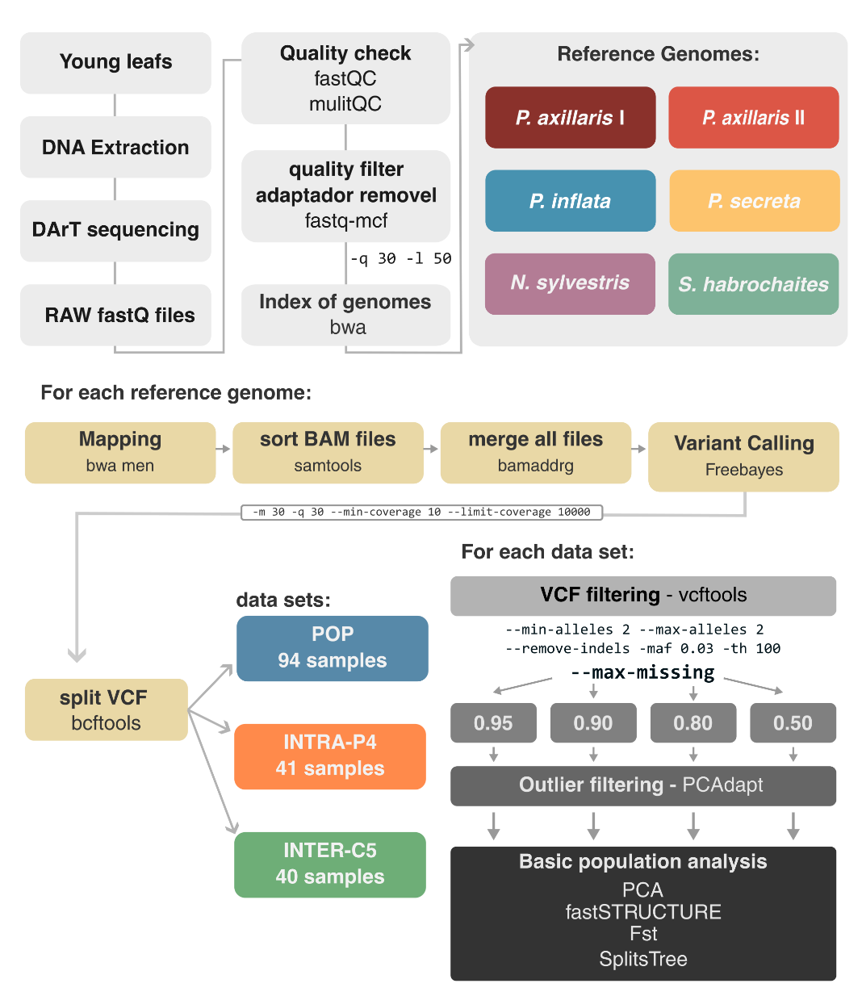
Figure 2. Analytical workflow summarizing the bioinformatic and population genomic analyses conducted in this study.

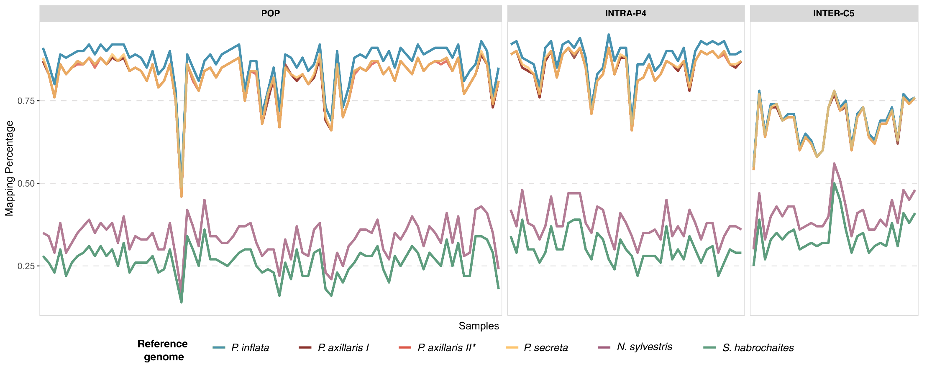Figure 3. Mapping rates for all individuals across datasets and reference genomes. Lines represent the proportion of mapped reads relative to the total number of reads per sample.

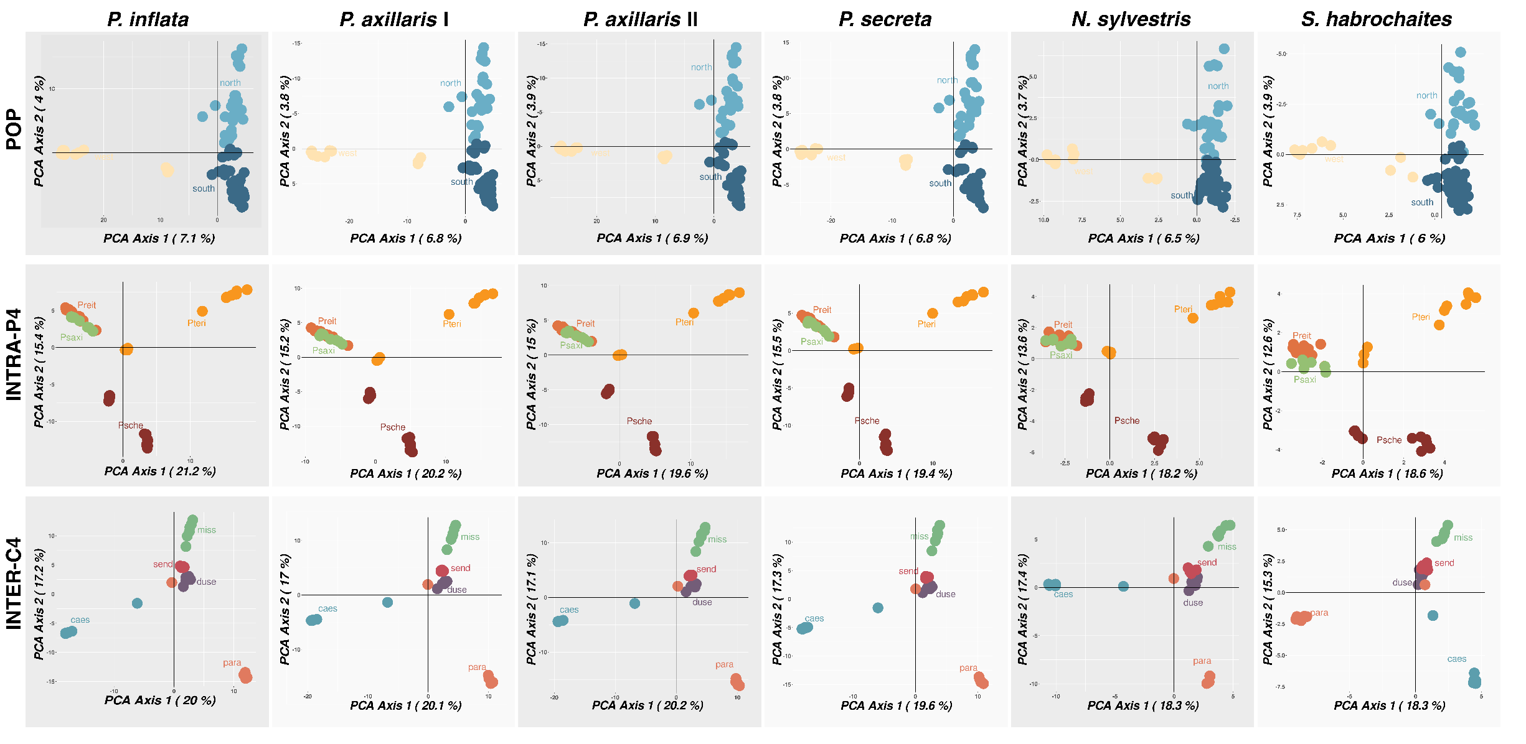
Figure 4. Principal Component Analyses (PCA) for each dataset using different reference genomes. Colors correspond to population or species groupings.
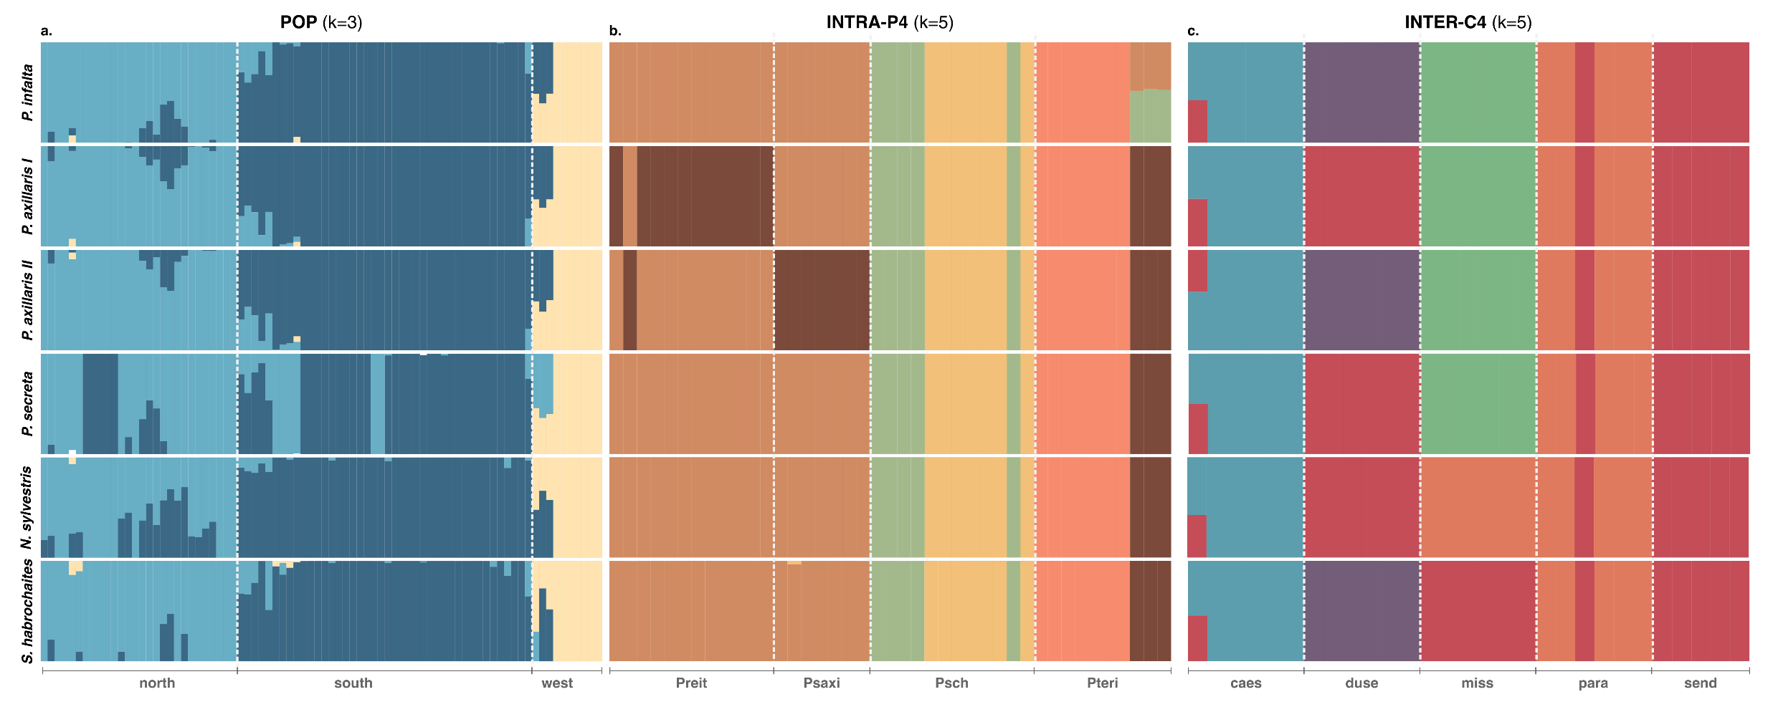
Figure 5. Population structure results from fastStructure analyses across all reference genomes for the three datasets: (a) POP, (b) INTRA-P4, and (c) INTER-C4. Each horizontal bar represents an individual, with colors indicating genetic cluster membership. Individuals are grouped by population (POP) or species (INTRA-P4, INTER-C4).
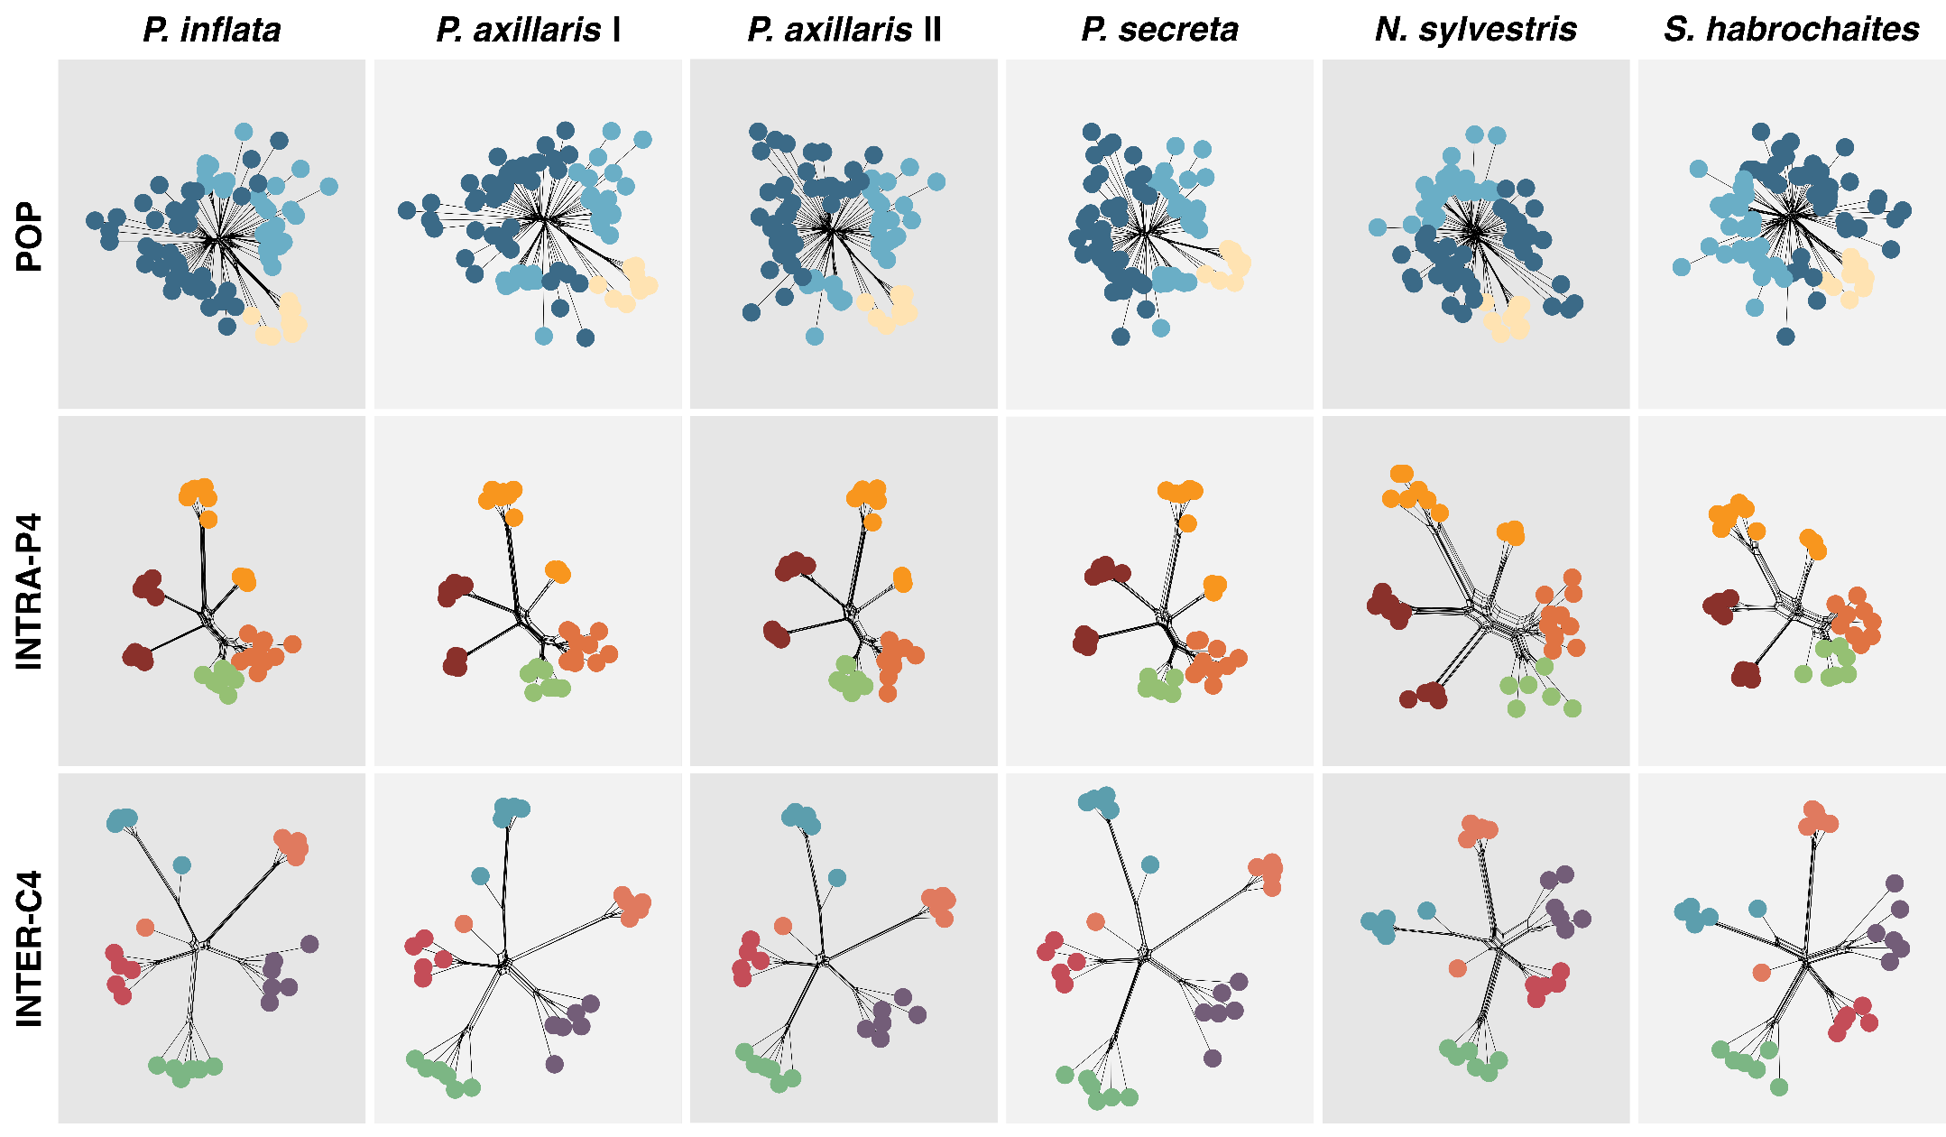
Figure 6. SPLITSTREE phylogenetic networks inferred for each dataset and reference genome. Colors indicate population or species identity according to the pattern.
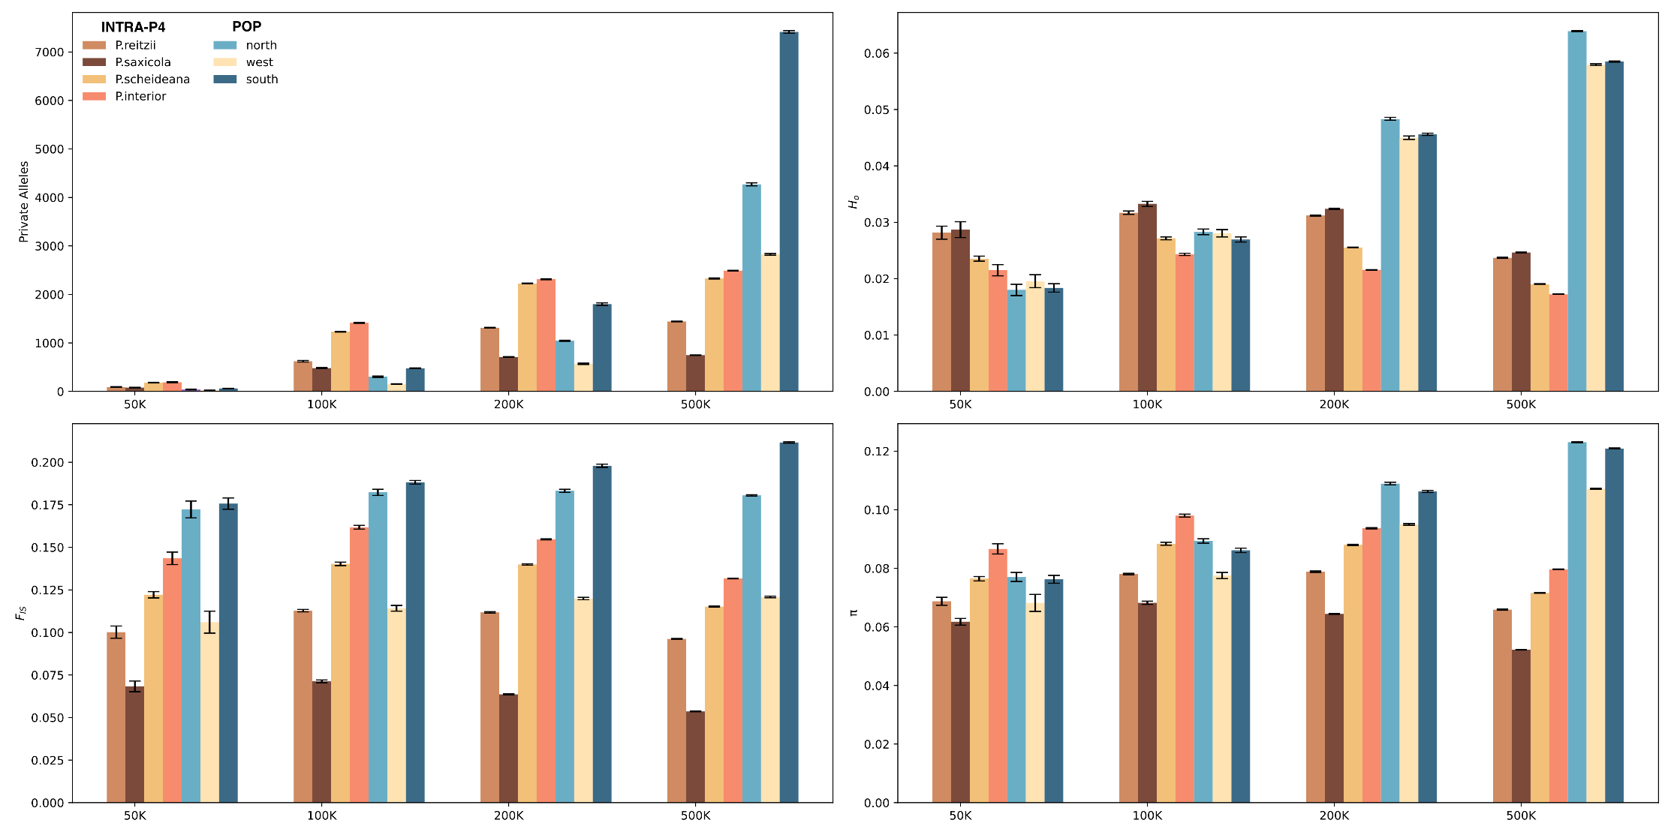
Supplementary Figure S1. Summary statistics including the number of private alleles, observed heterozygosity (Ho), inbreeding coefficient (F_{IS}), and nucleotide diversity (π) for each dataset under different levels of subsampled read counts. Bars are colored by dataset.

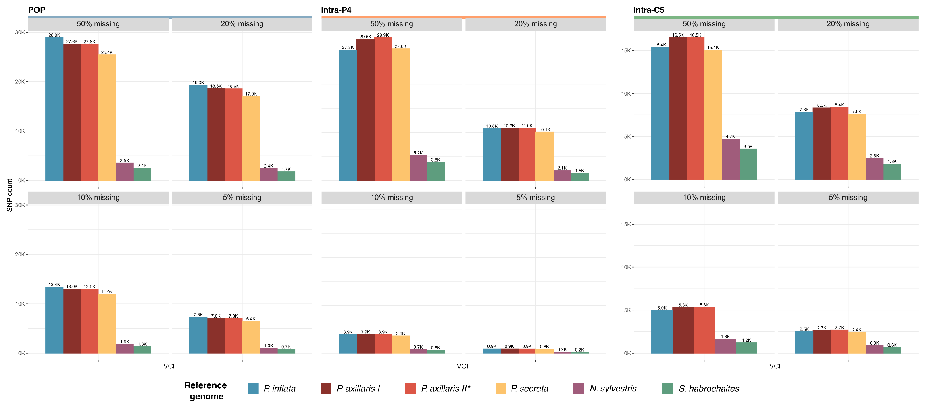
Supplementary Figure S2. Number of SNPs recovered across all datasets, reference genomes, and missing data thresholds applied during filtering.

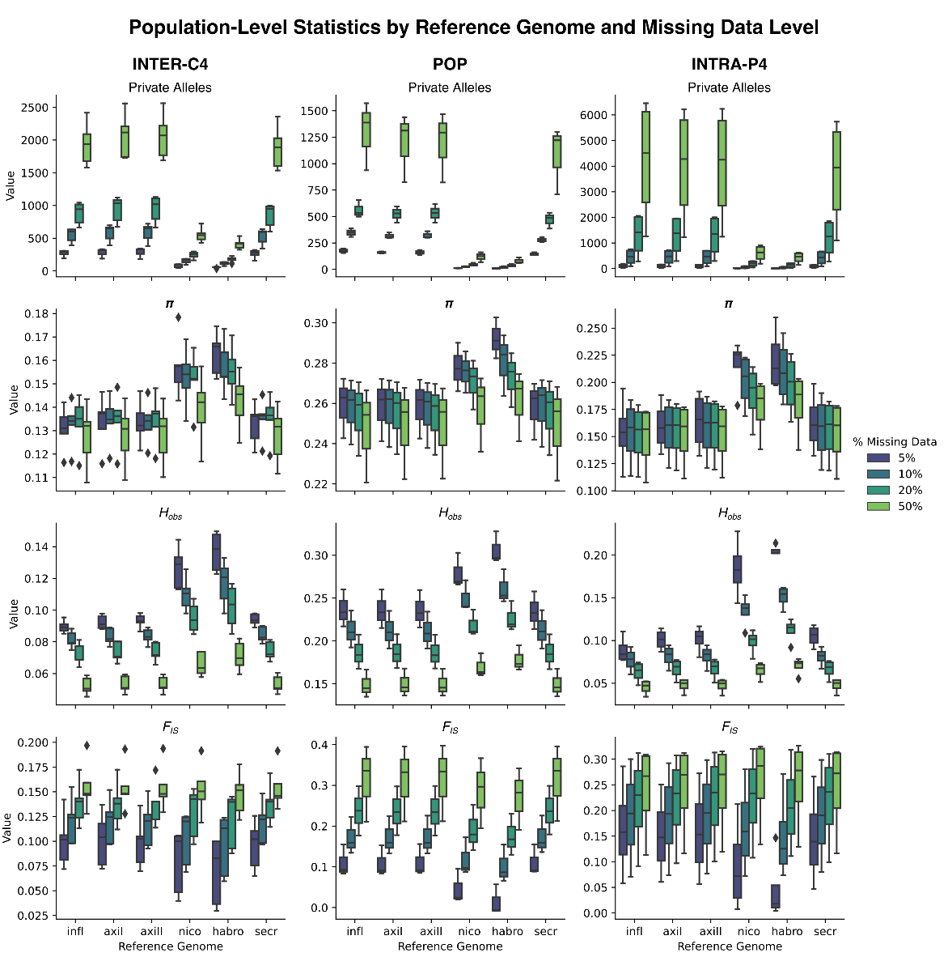
Supplementary Figure S3. Population-level genetic statistics (number of private alleles, nucleotide diversity (π), observed heterozygosity (Ho), and inbreeding coefficient (F_{IS})) across reference genomes and missing data thresholds. Reference genome abbreviations: Infl — P. inflata, AxiI — P. axillaris I, AxiII — P. axillaris II, Secr – P. secreta, Nico — Nicotiana sylvestris, Habro — Solanum habrochaites.
Table 1. Mapping rates (%) across datasets when mapped to different reference genomes, by their phylogenetic proximity to the focal taxa.
 | P. inflata | P. axillaris I | P. axillaris II | P. secreta | N. sylvestris | S. habrochaites
POP | 0.86 | 0.82 | 0.82 | 0.83 | 0.33 | 0.26
INTRA-P4 | 0.88 | 0.85 | 0.85 | 0.85 | 0.38 | 0.30
INTER-C5 | 0.69 | 0.68 | 0.68 | 0.68 | 0.41 | 0.34
POP - population-level dataset (80 P. altiplana individuals); Intra-P4 - intraspecific dataset (41 individuals of four Petunia species); Inter-C5 - interspecific dataset (40 individuals of five Calibrachoa species)

reference genome | alt80 |  |  |  | reference genome | grp41 |  |  |  |  | reference genome | phylo
aaxi |  | west | south |  |  |  | Psaxi | Psche | Pteri |  |  |  | duse | miss | para | send
aaxi | north | 0.09 | 0.04 |  | aaxi | Preit | 0.16 | 0.21 | 0.26 |  | aaxi | caes | 0.35 | 0.40 | 0.35 | 0.34
aaxi | west |  | 0.07 |  | aaxi | Psaxi |  | 0.24 | 0.31 |  | aaxi | duse |  | 0.33 | 0.29 | 0.28
axi |  |  |  |  | aaxi | Psche |  |  | 0.23 |  | aaxi | miss |  |  | 0.34 | 0.31
axi | north | 0.09 | 0.04 |  |  |  |  |  |  |  | aaxi | para |  |  |  | 0.29
axi | west |  | 0.08 |  | axi | Preit | 0.16 | 0.21 | 0.26
inf |  |  |  |  | axi | Psaxi |  | 0.24 | 0.31 |  | axi | caes | 0.35 | 0.39 | 0.34 | 0.34
inf | north | 0.09 | 0.04 |  | axi | Psche |  |  | 0.23 |  | axi | duse |  | 0.33 | 0.29 | 0.27
inf | west |  | 0.08 |  |  |  |  |  |  |  | axi | miss |  |  | 0.34 | 0.31
sec |  |  |  |  | infl | Preit | 0.16 | 0.22 | 0.27 |  | axi | para |  |  |  | 0.29
sec | north | 0.08 | 0.04 |  | infl | Psaxi |  | 0.24 | 0.32
sec | west |  | 0.07 |  | infl | Psche |  |  | 0.24 |  | infl | caes | 0.35 | 0.40 | 0.35 | 0.35
nico |  |  |  |  |  |  |  |  |  |  | infl | duse |  | 0.32 | 0.29 | 0.28
nico | north | 0.08 | 0.03 |  | sec | Preit | 0.16 | 0.21 | 0.26 |  | infl | miss |  |  | 0.34 | 0.31
nico | west |  | 0.07 |  | sec | Psaxi |  | 0.24 | 0.31 |  | infl | para |  |  |  | 0.30
habro |  |  |  |  | sec | Psche |  |  | 0.23
habro | north | 0.08 | 0.03 |  |  |  |  |  |  |  | sec | caes | 0.35 | 0.39 | 0.35 | 0.34
habro | west |  | 0.07 |  | nico | Preit | 0.15 | 0.19 | 0.23 |  | sec | duse |  | 0.33 | 0.29 | 0.28
 |  |  |  |  | nico | Psaxi |  | 0.21 | 0.27 |  | sec | miss |  |  | 0.34 | 0.31
 |  |  |  |  | nico | Psche |  |  | 0.21 |  | sec | para |  |  |  | 0.30
 |  |  |  |  | habro | Preit | 0.14 | 0.19 | 0.22 |  | nico | caes | 0.32 | 0.37 | 0.31 | 0.31
 |  |  |  |  | habro | Psaxi |  | 0.21 | 0.26 |  | nico | duse |  | 0.30 | 0.26 | 0.25
 |  |  |  |  | habro | Psche |  |  | 0.20 |  | nico | miss |  |  | 0.31 | 0.28
 |  |  |  |  |  |  |  |  |  |  | nico | para |  |  |  | 0.26
 |  |  |  |  |  |  |  |  |  |  | habro | caes | 0.30 | 0.34 | 0.30 | 0.29
 |  |  |  |  |  |  |  |  |  |  | habro | duse |  | 0.29 | 0.27 | 0.24
 |  |  |  |  |  |  |  |  |  |  | habro | miss |  |  | 0.31 | 0.27
 |  |  |  |  |  |  |  |  |  |  | habro | para |  |  |  | 0.26
Table S1 – Pairwise F_{ST} estimates by dataset and reference genome, summarizing genetic differentiation across population and species groups under each alignment scenario.
 | 50% missing |  |  |  |  |  | 20% missing |  |  |  |  |  | 10% missing |  |  |  |  |  | 5% missing
 | alt80 |  | grp |  | phylo |  | alt80 |  | grp |  | phylo |  | alt80 |  | grp |  | phylo |  | alt80 |  | grp |  | phylo
P. axillaris I | 2 | 5 | 5 | 5 | 4 | 4 | 2 | 5 | 5 | 5 | 5 | 5 | 2 | 4 | 10 | 5 | 4 | 5 | 2 | 6 | 5 | 5 | 5 | 5
P. axillaris II | 2 | 4 | 5 | 5 | 4 | 5 | 2 | 4 | 5 | 5 | 4 | 5 | 2 | 4 | 6 | 6 | 8 | 5 | 2 | 6 | 5 | 5 | 4 | 5
P. inflata | 2 | 4 | 5 | 5 | 4 | 4 | 2 | 5 | 5 | 6 | 4 | 4 | 2 | 5 | 4 | 6 | 4 | 5 | 2 | 6 | 4 | 5 | 4 | 5
P. secreta | 2 | 5 | 5 | 5 | 7 | 4 | 2 | 4 | 5 | 5 | 6 | 4 | 2 | 4 | 6 | 5 | 4 | 5 | 2 | 5 | 4 | 5 | 4 | 5
N. sylvestis | 2 | 6 | 5 | 5 | 4 | 4 | 2 | 5 | 8 | 5 | 4 | 5 | 2 | 5 | 5 | 5 | 4 | 4 | 2 | 5 | 4 | 5 | 4 | 5
S. habrochaites | 2 | 6 | 7 | 5 | 4 | 4 | 2 | 8 | 5 | 5 | 5 | 5 | 3 | 6 | 5 | 5 | 4 | 4 | 2 | 4 | 3 | 5 | 4 | 4

Table S2. Range of K values estimated by fastStructure analyses across reference genomes, datasets, and missing data thresholds. Shown K are those that maximize marginal likelihood (model complexity), and the K values selected to best describe the genetic structure in each dataset.

CONSIDERAÇÕES FINAIS
Desde Darwin, uma das questões centrais da biologia evolutiva é compreender os processos responsáveis pela grande diversificação de espécies — ou seja, como diferentes espécies se originam a partir de uma população ancestral (Diamond, 1977; Grant, 1981; Coyne & Orr, 2004; Nosil & Feder, 2012). Esse processo pode ocorrer em diferentes ritmos, com algumas linhagens diversificando lentamente e outras passando por rápidas radiações. Diversificações rápidas, em particular, tornam a identificação dos mecanismos responsáveis por esse processo uma tarefa desafiadora, já que o curto intervalo entre os eventos de divergência dificulta distinguir os fatores históricos, ecológicos e genéticos que atuaram. Em geral, dinâmicas como flutuações climáticas, isolamento geográfico e interações ecológicas moldam as oportunidades e restrições que determinam os padrões de diversificação observados em diferentes grupos. Esta tese contribui para o entendimento dessa questão tão relevante e fascinante da biologia evolutiva.
Ao investigar a diversificação das espécies de altitude de Petunia, observamos um retrato de um contínuo de especiação, e não um processo concluído com barreiras bem estabelecidas há muito tempo entre as linhagens. Os resultados mostraram linhagens evoluindo independentemente, mas com evidências de fluxo gênico entre elas e a persistência de polimorfismos ancestrais. Além disso, as diferenças morfológicas entre essas linhagens são sutis, o que torna esse sistema particularmente interessante e complexo para o estudo dos mecanismos que moldam a diversificação de espécies.
Iniciamos essa tese com a atualização da filogenia do gênero Petunia, resolvendo questões taxonômicas que vinham sendo investigadas com os estudos do nosso grupo de pesquisa: reconhecemos P. axillaris, P. parodii e P. subandina como espécies independentes, elevamos P. integrifolia depauperata à categoria de espécies como P. dichotoma. Mas principalmente, os resultados evidenciaram questões ainda não resolvidas sobre a história evolutiva do clado de tubo curto da corola, enfatizando a necessidade de investigações adicionais sobre sua diversificação e estrutura genética, o que trabalhamos no decorrer da tese.
No primeiro trabalho que investigou as relações evolutivas entre as espécies analisadas nesta tese, Lorenz-Lemke et al. (2010), utilizando dados de cpDNA, identificaram um grande compartilhamento de haplótipos entre as espécies e sugeriram a existência de uma população ancestral amplamente distribuída, com fluxo gênico limitado, na qual algumas populações alopátricas passaram por processos rápidos de especiação. Esse padrão pôde ser retomado aqui com abordagem genômica, que revela com maior resolução, os detalhes das histórias evolutivas dessas espécies e os mecanismos que impulsionaram sua diversificação.
Em nível populacional, analisamos a estruturação e a filogeografia da espécie de distribuição mais ampla nos campos de altitude, P. altiplana (Capítulo 2), e identificamos um conjunto de fatores responsáveis pela estruturação de suas populações. O isolamento por distância se destacou como o principal, seguido pela diferença atitudinal, pela presença de rios atuando como barreiras, além da dinâmica biogeográfica da região, que, em conjunto, promoveram a redução do fluxo gênico e favoreceram a estruturação populacional.
Em nível interespecífico, investigamos dois pares de espécies irmãs submetidos a processos distintos de diferenciação: P. guarapuavensis e P. scheideana (Capítulo 3) e P. reitzii e P. saxicola (Capítulo 4). O caso de P. guarapuavensis e P. scheideana exemplifica uma separação entre linhagens que não resultou em diferenças morfológicas suficientemente marcantes levando a intenso debate sobre seu reconhecimento como espécies distintas, embora geneticamente representem linhagens evoluindo de forma independente há certo tempo. Essas duas espécies haviam sido sinonimizadas devido à similaridade morfológica (Stehmann et al., 2009), e até então os estudos genéticos haviam apresentado resultados conflitantes (Lorenz-Lemke et al., 2010; Reck-Kortmann et al., 2014; Souza et al., 2024). Com as análises genômicas realizadas nesta tese, foi possível compreender melhor essa relação. Nossos resultados indicam que P. scheideana e P. guarapuavensis são espécies independentes, sendo que as populações de P. guarapuavensis apresentam forte estruturação. Uma dessas populações (Capítulos 3 e 4) foi responsável pela confusão taxonômica anterior, pois, embora geneticamente pertença à espécie P. guarapuavensis, exibe características morfológicas mais próximas de P. scheideana. Propusemos que essa população esteja em um processo inicial de diferenciação. Quando analisadas em conjunto com outras espécies, essas linhagens reforçam seus status de espécies independentes, comportando-se como espécies irmãs (Capítulos 3 e 4).
Petunia reitzii e P. saxicola exibiram um padrão quase oposto ao descrito anteriormente. Essas espécies irmãs são geneticamente muito semelhantes, agrupando-se consistentemente em todas as análises estruturais e filogenéticas realizadas, sendo distinguíveis apenas quando analisadas isoladamente do restante do grupo. No entanto, ocupam ambientes completamente distintos ecologicamente, o que indica que, apesar da baixa diferenciação genética, essas linhagens estão trilhando trajetórias ecológicas e evolutivas diferentes. Esse padrão sugere que P. reitzii e P. saxicola possam ser diferenciadas principalmente por meio de especiação ecológica, na qual a adaptação a diferentes habitats funciona como principal mecanismo de isolamento e divergência (Nosil, 2012).
Petunia inflata e P. interior foram incluídas nesse trabalho por seu potencial papel na expansão do gênero para as terras altas, e sua inclusão se revelou ainda mais interessante do que prevíamos. Essas foram as únicas espécies que não recuperaram a monofilia nas análises (Capítulos 4 e 5). Cada uma foi subdividida em duas linhagens geneticamente bem distintas, um resultado que, embora explorado de forma preliminar nesta tese, demanda investigações mais aprofundadas. A revisão morfológica (Capítulo 5) das amostras dessas linhagens discordantes revelou que, apesar da forte diferenciação genética, todas mantêm as características morfológicas típicas da espécie a qual foram atribuídas, o que torna o caso ainda mais intrigante e relevante para futuros estudos sobre diversidade críptica e processos de especiação no grupo.

A busca por hibridação
Ao identificarmos as linhagens divergentes dentro de P. guarapuavensis e a alta divergência de P. scheideana em relação a essas linhagens, não tínhamos clareza sobre a posição filogenética exata de P. scheideana em relação às demais. Levantamos a hipótese de que a diferenciação observada dentro das linhagens de P. guarapuavensis poderia resultar de eventos de hibridação ou introgressão com outras espécies próximas. Por isso, a cada capítulo ampliamos a amostragem de espécies na tentativa de identificar sinais dessa mistura, mantendo a subdivisão dessas linhagens ao longo dos estudos. O principal impulsionador para essa hipótese é que a hibridação é um fenômeno recorrente nas linhagens de Petunia, com diversos registros na literatura (Lorenz-Lemke et al., 2006; Turchetto et al., 2015, 2019a, 2019b; Giudicelli et al., 2019, 2024; Teixeira et al., 2019; Caballero-Villalobos et al., 2021; Pezzi et al., 2022, 2024). No entanto, não encontramos evidências de híbridos de poucas gerações entre as linhagens analisadas, com exceção de um indivíduo de P. guarapuavensis que possivelmente resultou de hibridação recente entre duas populações vizinhas. A ausência de híbridos recentes reforça a hipótese de isolamento entre essas linhagens, nas ilhas de altitude (Magaldi et al., 2024), provocado pela expansão da floresta com Araucária, que, ao circundar os campos de altitude, dificulta o contato secundário entre as espécies.
No Capítulo 4, ao observarmos uma linhagem de P. interior filogeneticamente mais próxima das espécies de altitude, levantamos a possibilidade de se tratar de um híbrido. Testamos diversos pares de possíveis parentais para essa linhagem e, curiosamente, todos poderiam ter contribuído geneticamente para sua formação. Dessa forma, os resultados indicaram que, em vez de uma linhagem híbrida, identificamos uma linhagem que conserva altos níveis de polimorfismo ancestral, provavelmente remanescente da população ancestral importante na diversificação das linhagens de tubo curto.

Colonização das terras altas e diversificação das espécies influenciadas pelo Pleistoceno
Em conjunto, os capítulos apresentados nesta tese permitiram reconstruir parte da história da colonização das terras altas por espécies de Petunia a partir dos campos de baixa altitude. No Capítulo 2, evidenciamos um padrão de expansão das áreas mais baixas para as de altitude, sustentado pela maior diversidade genética encontrada nas populações de P. altiplana em elevações inferiores, sugerindo a atuação de um efeito fundador no processo de colonização (Futuyma & Kirkpatrick, 2017).
No capítulo 4 identificamos uma linhagem divergente de P. interior e propusemos que ela estaria mais próxima do ancestral das populações de altitude, por apresentar um amplo polimorfismo ancestral compartilhado com as demais espécies de altitude investigadas. Esse padrão se confirmou no Capítulo 5, quando as espécies foram analisadas em conjunto. Essa linhagem divergente se mostrou intimamente relacionada à população de P. altiplana de maior diversidade genética identificada no Capítulo 2. Essas duas populações compartilham padrões genéticos bastante similares, marcados por alto polimorfismo ancestral, embora sejam morfologicamente distintas — um cenário que reforça a existência de uma população ancestral amplamente distribuída e conectada, que colonizou as terras altas e, posteriormente, foi fragmentada (Lorenz-Lemke et al., 2010) pelo avanço da floresta com Araucária.
No Capítulo 5 também detectamos a persistência desse polimorfismo ancestral em praticamente todas as linhagens analisadas, resultado esperado diante do rápido processo de diversificação dessas espécies durante o Pleistoceno. Por meio de abordagens adequadas, conseguimos distinguir polimorfismo ancestral de fluxo gênico, demonstrando que, apesar de atualmente fragmentadas, essas linhagens apresentavam elevada conectividade genética no passado através de populações que tenham sido extintas pelas mudanças geoclimáticas ou, mais recentemente, pela ação antrópica. Não é possível descartar fluxo gênico atual através de populações intermediárias ainda não amostradas, embora os esforções na busca pelas espécies.
A diversificação dessas linhagens ocorreu sob forte influência das oscilações climáticas do Pleistoceno, período em que os ciclos glaciais mais frios e úmidos favoreceram a expansão das espécies de campo, como Petunia, e ampliaram sua distribuição (Behling, 2002; Barros et al., 2015, 2020). Durante esse intervalo, as populações ancestrais provavelmente mantinham forte conectividade, que foi recentemente progressivamente perdida com a expansão das florestas — especialmente da Floresta com Araucária (Iriarte & Behling, 2007) — nas fases mais quentes e úmidas subsequentes, fragmentando os campos de altitude e isolando as populações remanescentes (Lorenz-Lemke et al., 2010).
A ocorrência de P. mantiqueirensis, restrita atualmente à Serra da Mantiqueira — a aproximadamente 600 km da linhagem mais ao norte nos Campos de Cima da Serra —, constitui uma evidência adicional dessa antiga conectividade. No Capítulo 5, mostramos que essa espécie compartilha significativo polimorfismo ancestral e sinais de fluxo gênico ancestral com as demais linhagens, sugerindo que, durante os picos de expansão da vegetação campestre no Pleistoceno, as linhagens ancestrais de Petunia ocuparam amplamente essas áreas. Na Serra da Mantiqueira, ainda sobrevivem raros fragmentos de Floresta de Araucária (Ab’Sáber, 2003; Backes, 2009; Furtado et al., 2016), reforçando a ideia de que essa região atuou como um refúgio climático e ambiental também para Petunia. Assim como já documentado para outras espécies associadas aos campos de altitude, as populações remanescentes dessa região preservam vestígios importantes de uma história evolutiva marcada por ciclos de conexão e isolamento (Carnaval et al., 2009; Guillory et al., 2024; Pereira et al., 2021; Magaldi et al., 2024).

A importância da metodologia
Trabalhar com espécies que divergiram recentemente exige alto rigor metodológico, sobretudo para lidar com os desafios inerentes a esses sistemas, como a incongruência entre métodos e principalmente pela presença de polimorfismo ancestral e fluxo gênico (Carstens et al., 2013; Kapli, 2020; Steenwyk et al., 2023). Ao longo deste trabalho, evidenciamos como uma abordagem abrangente, integrando diferentes métodos de estruturação populacional, delimitação de espécies e inferência filogenética, é essencial para lidar com essas incongruências e compreender de forma mais precisa os padrões evolutivos. Ressaltamos, inclusive, que, em sistemas marcados por rápida diversificação e fluxo gênico, redes filogenéticas são mais adequadas do que árvores dicotômicas tradicionais, pois são capazes de representar relações reticuladas e histórias evolutivas complexas de maneira mais fiel.
O caso de rápida divergência das espécies analisadas também nos permitiu investigar um aspecto metodológico relevante, cujo resultado contraria a expectativa mais intuitiva (Capítulo 6). Trata-se da escolha do genoma de referência para o mapeamento dos dados. A recomendação recorrente na literatura sugere utilizar o genoma mais próximo filogeneticamente do grupo de estudo quando não há um genoma disponível da própria espécie (Therkildsen & Palumbi, 2017; Galla et al., 2018). No entanto, nossos resultados indicam que, em contextos de diversificação recente e rápida, essa recomendação nem sempre se aplica. Para as espécies de Petunia analisadas, qualquer um dos genomas de referência disponíveis do gênero foi capaz de recuperar resultados consistentes para as análises de estruturação populacional e de inferência da história evolutiva. Mesmo genomas de espécies mais distantes, como de táxons fora do grupo focal, ainda foram capazes de gerar resultados satisfatórios. Mais ainda, os genomas de Petunia apresentaram desempenho satisfatório na recuperação de variantes para espécies de um gênero próximo, Calibrachoa, que divergiu há menos de 10 milhões de anos, superando inclusive a abordagem de novo em termos de recuperação de SNPs, cujo número e percentagem de dados faltantes impacta mais nas estimativas de diversidade e relações evolutivas que a proximidade do genoma.
Esse achado é especialmente relevante para pesquisadores que trabalham com espécies não-modelo e enfrentam limitações orçamentárias para sequenciamento de genomas completos de táxons próximos. Os resultados aqui apresentados sugerem que, em sistemas marcados por divergência recente, é possível obter inferências evolutivas robustas utilizando genomas de referência de espécies relacionadas, reduzindo custos e viabilizando estudos genômicos mesmo em contextos com recursos limitados.

BIBLIOGRAFIA
(referências citadas na Introdução e Considerações Finais)
Ab’Saber; Aziz N (2003) Os domínios de Natureza no Brasil - Potencialidades Paisagísticas. Ateliê Editorial
Adams DC, Berns CM, Kozak KH and Wiens JJ (2009) Are rates of species diversification correlated with rates of morphological evolution? Proc. R. Soc. B 276:2729–2738.
Andrews KR, Good JM, Miller MR, Luikart G and Hohenlohe PA (2016) Harnessing the power of RADseq for ecological and evolutionary genomics. Nat. Rev. Genet 2016 17:2 17:81–92.
Arnegard ME, McGee MD, Matthews B, Marchinko KB, Conte GL, Kabir S, Bedford N, Bergek S, Chan YF, Jones FC et al. (2014) Genetics of ecological divergence during speciation. Nature 511:307–311.
Avise JC, Shapira JF, Daniel S. W, Aquadro CF and Lansman RA (1983) Mitochondrial DNA differentiation during the speciation process in Peromyscus. Mol Biol Evol 1:38–56.
Baack E, Melo MC, Rieseberg LH and Ortiz‐Barrientos D (2015) The origins of reproductive isolation in plants. New Phytol. 207:968–984.
Backes A (2009) Distribuição geográfica atual da Floresta com Araucária: condicionamento climático. In: Fonseca CR, Souza AF, Leal-Zanchet AM, Dutra T, Backes A, Ganado G. (eds.) Floresta com Araucária: Ecologia, conservação e desenvolvimento sustentável. Ribeirão Preto, Holos Editora. p. 137-148.
Backes A, Mäder G, Turchetto C, Segatto AL, Fregonezi JN, Bonatto SL and Freitas LB (2019) How diverse can rare species be on the margins of genera distribution? AoB Plants. doi: 10.1093/aobpla/plz037
Backes A, Turchetto C, Mäder G, Segatto ALA, Bonatto SL and Freitas LB (2024) Shades of white: The Petunia long corolla tube clade evolutionary history. Genet Mol Biol. doi: 10.1590/1415-4757-gmb-2023-0279
Baker PA, Fritz SC, Battisti DS, Dick CW, Vargas OM, Asner GP, Martin RE, Wheatley A and Prates I (2020) Beyond Refugia: New Insights on Quaternary Climate Variation and the Evolution of Biotic Diversity in Tropical South America. 51–70.
Barres L, Batalha-Filho H, Schnadelbach AS and Roque N (2019) Pleistocene climatic changes drove dispersal and isolation of Richterago discoidea (Asteraceae), an endemic plant of campos rupestres in the central and eastern Brazilian sky islands. Bot J Lin Soc 189:132–152.
Barros MJF, Silva-Arias GA, Fregonezi JN, Turchetto-Zolet AC, Iganci JRV, Diniz-Filho JAF and Freitas LB (2015) Environmental drivers of diversity in Subtropical Highland Grasslands. Perspect Plant Ecol Evol Syst 17:360–368.
Barros MJF, Silva-Arias GA, Segatto ALA, Reck-Kortmann M, Fregonezi JN, Diniz-Filho JAF and Freitas LB (2020) Phylogenetic niche conservatism and plant diversification in South American subtropical grasslands along multiple climatic dimensions. Genet Mol Biol. doi: 10.1590/1678-4685-gmb-2018-0291
Barton NH and Hewitt GM (1985) Analysis of Hybrid Zones. Annu Rev Ecol Syst 16:113–148.
Beausoleil M-O, Carrión PL, Podos J, Camacho C, Rabadán-González J, Richard R, Lalla K, Raeymaekers JAM, Knutie SA, De León LF et al. (2023) The fitness landscape of a community of Darwin’s finches. Evolution (N Y) 77:2533–2546.
Behling H (2002) South and southeast Brazilian grasslands during Late Quaternary times: a synthesis. Palaeogeogr Palaeoclimatol Palaeoecol 177:19–27.
Bock DG, Cai Z, Elphinstone C, González-Segovia E, Hirabayashi K, Huang K, Keais GL, Kim A, Owens GL and Rieseberg LH (2023) Genomics of plant speciation. Plant Commun 4:100599.
Bolnick DI and Otto SP (2013) The magnitude of local adaptation under genotype-dependent dispersal. Ecol Evol 3:4722–4735.
Bombarely A, Moser M, Amrad A, Bao M, Bapaume L, Barry CS, Bliek M, Boersma MR, Borghi L, Bruggmann R et al. (2016) Insight into the evolution of the Solanaceae from the parental genomes of Petunia hybrida. Nat Plants 2:16074.
Byars SG, Parsons Y and Hoffmann AA (2009) Effect of altitude on the genetic structure of an Alpine grass, Poa hiemata. Ann Bot 103:885–899.
Caballero-Villalobos L, Silva-Arias GA, Turchetto C, Giudicelli GC, Petzold E, Bombarely A and Freitas LB (2021) Neutral and adaptive genomic variation in hybrid zones of two ecologically diverged Petunia species (Solanaceae). Bot J Lin Soc 196:100–122.
Cai L, Xi Z, Lemmon EM, Lemmon AR, Mast A, Buddenhagen CE, Liu L and Davis CC (2021) The perfect storm: gene tree estimation error, incomplete lineage sorting, and ancient gene flow explain the most recalcitrant ancient angiosperm clade, Malpighiales. Syst Biol 70:491–507.
Carnaval AC, Hickerson MJ, Haddad CFB, Rodrigues MT and Moritz C (2009) Stability predicts genetic diversity in the Brazilian Atlantic Forest hotspot. Science (1979) 323:785–789.
Carnaval AC, Waltari E, Rodrigues MT, Rosauer D, VanDerWal J, Damasceno R, Prates I, Strangas M, Spanos Z, Rivera D et al. (2014) Prediction of phylogeographic endemism in an environmentally complex biome. Proc. R. Soc. B 281:20141461.
Carstens BC, Pelletier TA, Reid NM and Satler JD (2013) How to fail at species delimitation. Mol Ecol 22:4369–4383.
Contreras-Ortiz N, Atchison GW, Hughes CE and Madriňán S (2018) Convergent evolution of high elevation plant growth forms and geographically structured variation in Andean Lupinus (Fabaceae). Bot J Lin Soc 187:118–136.
Coyne JA and Orr HA (2004) Speciation, 1º. OUP USA, Sunderland, MA.
Croteau EK (2010) Causes and consequences of dispersal in plants and animals. Nat. Sci. Educ 3:12.
Dantas‐Queiroz MV, Hurbath F, de Russo-Godoy FM, Lanna FM, Versieux LM and Palma‐Silva C (2023) Comparative phylogeography reveals the demographic patterns of neotropical ancient mountain species. Mol Ecol 32:3165–3181.
Davey JL and Blaxter MW (2010) RADSeq: next-generation population genetics. Brief Funct Genomics 9:416–423.
de Queiroz K (2007) Species concepts and species delimitation. Syst Biol 56:879–886.
Diamond JM (1977) Continental and insular speciation in pacific land birds. Syst Zool 26:263.
Doyle JJ (1992) Gene trees and species trees: molecular systematics as one-character taxonomy. Syst Bot 17:144.
Eaton DAR and Ree RH (2013) Inferring phylogeny and introgression using RADseq data: an example from flowering plants (Pedicularis: Orobanchaceae). Syst Biol 62:689–706.
Edet OU, Gorafi YSA, Nasuda S and Tsujimoto H (2018) DArTseq-based analysis of genomic relationships among species of tribe Triticeae. Sci Rep 8:16397.
Ellegren H (2014) Genome sequencing and population genomics in non-model organisms. Trends Ecol Evol 29:51–63.
Epps CW and Keyghobadi N (2015) Landscape genetics in a changing world: disentangling historical and contemporary influences and inferring change. Mol Ecol 24:6021–6040.
Feder JL, Flaxman SM, Egan SP and Nosil P (2013) Hybridization and the build‐up of genomic divergence during speciation. J Evol Biol 26:261–266.
Fišer C, Robinson CT and Malard F (2018) Cryptic species as a window into the paradigm shift of the species concept. Mol Ecol 27:613–635.
Fregonezi JN, Turchetto C, Bonatto S and Freitas LB (2013) Biogeographical history and diversiﬁcation of Petunia and Calibrachoa (Solanaceae) in the Neotropical Pampas grassland. Bot J Lin Soc 171:140–153.
Freitas LB (2022) A perspective on the centre-periphery hypothesis: some examples in Petunia and other Neotropical taxa. Bot J Lin Soc 199:228–234.
Furtado SG and Menini Neto L (2016) Vascular epiphytic flora of a high montane environment of Brazilian Atlantic Forest: composition and floristic relationships with other ombrophilous forests. Acta Bot Bras 30:422–436.
Futuyma DJ and Kirkpatrick M (2017) Evolution, 4th ed. Sinauer Associates, INC
GADOW H (1906) A contribution to the study of evolution based upon the Mexican species of Cnemidophorus. Proc Zool Soc Lond 76:277–375.
Galla SJ, Forsdick NJ, Brown L, Hoeppner MP, Knapp M, Maloney RF, Moraga R, Santure AW and Steeves TE (2019) Reference genomes from distantly related species can be used for discovery of single nucleotide polymorphisms to inform conservation management. Genes 10:9.
Giudicelli GC, Pezzi PH, Guzmán-Rodriguez S, Turchetto C, Bombarely A and Freitas LB (2024) Historical and ongoing hybridisation in Southern South American grassland species. Sci Rep 14:27989.
Giudicelli GC, Turchetto C, Guzmán-Rodriguez S, Teixeira MC, Petzold E, Bombarely A and Freitas LB (2022) Population genomics indicates micro-refuges and riverine barriers for a southern South American grassland nightshade. J Biogeogr 49:51–65.
Giudicelli GC, Turchetto C, Teixeira MC and Freitas LB (2019) Morphological and genetic characterisation in putative hybrid zones of Petunia axillaris subsp. axillaris and subsp. parodii (Solanaceae). Bot J Lin Soc 191:353-364.
Godinho MBC and da Silva FR (2018) The influence of riverine barriers, climate, and topography on the biogeographic regionalization of Amazonian anurans. Sci Rep 8:3427.
Grant V (1981) Plant Speciation. doi: 10.7312/gran92318
Greppi Ja, Hagiwara Jc and Stehmann Jr (2019) A new species of Petunia (Solanaceae) from Corrientes, Argentina. Phytotaxa 414:289–295.
Guillory WX, de Medeiros-Magalhães F, Coelho FEA, Bonatelli IAS, Palma‐Silva C, Moraes EM, Garda AA, Burbrink FT and Gehara M (2024) Geoclimatic drivers of diversification in the largest arid and semi‐arid environment of the Neotropics: Perspectives from phylogeography. Mol Ecol 33:e17431.
Günther T and Nettelblad C (2019) The presence and impact of reference bias on population genomic studies of prehistoric human populations. PLoS Genet 15:e1008302.
Hending D (2025) Cryptic species conservation: a review. Biol Rev 100:258–274.
Hernández‐Hernández T, Miller EC, Román‐Palacios C and Wiens JJ (2021) Speciation across the Tree of Life. Biol Rev 96:1205–1242.
Herrera CM and Bazaga P (2008) Adding a third dimension to the edge of a species’ range: altitude and genetic structuring in mountainous landscapes. Heredity 100:275–285.
Iganci JR V., Heiden G, Miotto STS and Pennington RT (2011) Campos de Cima da Serra: the Brazilian Subtropical Highland Grasslands show an unexpected level of plant endemism. Bot J Lin Soc 167:378–393.
Iriarte J and Behling H (2007) The expansion of Araucaria Forest in the southern Brazilian highlands during the last 4000 years and its implications for the development of the Taquara/Itararé Tradition. Environ Archaeol 12:115–127.
Jamie GA and Meier JI (2020) The persistence of polymorphisms across species radiations. Trends Ecol Evol 35:795–808.
John AL de W, Mäder G, Fregonezi JN and Freitas LB (2019) Genetic diversity and population structure of naturally rare Calibrachoa species with small distribution in southern Brazil. Genet Mol Biol 42:108–119.
Kapli P, Yang Z and Telford MJ (2020) Phylogenetic tree building in the genomic age. Nat Rev Genet 21:428–444.
Kimura M and Weiss GH (1964) The stepping stone model of population structure and the decrease of genetic correlation with distance. Genetics 49:561–576.
Kulcheski FR, Muschner VC, Lorenz-Lemke AP, Stehmann JR, Bonatto SL, Salzano FM and Freitas LB (2006) Molecular phylogenetic analysis of Petunia Juss. (Solanaceae). Genetica 126:3–14.
Lagomarsino LP, Condamine FL, Antonelli A, Mulch A and Davis CC (2016) The abiotic and biotic drivers of rapid diversification in Andean bellflowers (Campanulaceae). New Phytol 210:1430–1442.
Ledru MP, Salatino MLF, Ceccantini G, Salatino A, Pinheiro F and Pintaud JC (2007) Regional assessment of the impact of climatic change on the distribution of a tropical conifer in the lowlands of South America. Divers Distrib 13:761–771.
Lee CR and Mitchell-Olds T (2011) Quantifying effects of environmental and geographical factors on patterns of genetic differentiation. Mol Ecol 20:4631–4642.
Longo D, Lorenz-Lemke AP, Mäder G, Bonatto SL and Freitas LB (2014) Phylogeography of the Petunia integrifolia complex in southern Brazil. Bot J Lin Soc 174:199–213.
Lorenz-Lemke AP, Mäder G, Muschner VC, Stehmann JR, Bonatto SL, Salzano FM and Freitas LB (2006) Diversity and natural hybridization in a highly endemic species of Petunia (Solanaceae): a molecular and ecological analysis. Mol Ecol 15:4487–4497.
Lorenz-Lemke AP, Togni PD, Mäder G, Kriedt RA, Stehmann JR, Salzano FM, Bonatto SL and Freitas LB (2010) Diversification of plant species in a subtropical region of eastern South American highlands: a phylogeographic perspective on native Petunia (Solanaceae). Mol Ecol 19:5240–5251.
Maddison WP (1997) Gene trees in species trees. Syst Biol 46:523–536.
Maddison WP and Knowles LL (2006) Inferring phylogeny despite incomplete lineage sorting. Syst Biol 55:21–30.
Mäder G and Freitas LB (2019) Biogeographical, ecological, and phylogenetic analyses clarifying the evolutionary history of Calibrachoa in South American grasslands. Mol Phylogenet Evol 141:106614.
Magaldi L de M, Gueratto PE, Ortega‐Abboud E, Sobral‐Souza T, Joron M, de Souza AP, Freitas AVL and Silva‐Brandão KL (2024) Montane diversification as a mechanism of speciation in neotropical butterflies. Ecol Evol 14:e11704.
Mallet J (2005) Hybridization as an invasion of the genome. Trends Ecol Evol 20:229–237.
Martin CH and Richards EJ (2019) The paradox behind the pattern of rapid adaptive radiation: how can the speciation process sustain itself through an early burst? Annu Rev Ecol Evol Syst 50:569–593.
Martins NT, Macagnan LB, Cassano V and Gurgel CFD (2022) Brazilian marine phylogeography: A literature synthesis and analysis of barriers. Mol Ecol 31:5423–5439.
Melo‐Ferreira J, Boursot P, Suchentrunk F, Ferrand N and Alves PC (2005) Invasion from the cold past: extensive introgression of mountain hare (Lepus timidus) mitochondrial DNA into three other hare species in northern Iberia. Mol Ecol 14:2459–2464.
Meyer BS, Matschiner M and Salzburger W (2017) Disentangling incomplete lineage sorting and introgression to refine species-tree estimates for Lake Tanganyika cichlid fishes. Syst Biol 66:531-550.
Moyle RG, Filardi CE, Smith CE and Diamond J (2009) Explosive Pleistocene diversification and hemispheric expansion of a “great speciator.” PNAS 106:1863–1868.
Muir G and Schlötterer C (2005) Evidence for shared ancestral polymorphism rather than recurrent gene flow at microsatellite loci differentiating two hybridizing oaks (Quercus spp.). Mol Ecol 14:549–561.
NOSIL P (2008) Speciation with gene flow could be common. Mol Ecol 17:2103–2106.
Nosil P (2012) Ecological Speciation. Oxford University Press, Oxford, United Kingdom
Nosil P and Feder JL (2012) Genomic divergence during speciation: causes and consequences. Proc R Soc B 367:332–342.
Ohsawa T and Ide Y (2008) Global patterns of genetic variation in plant species along vertical and horizontal gradients on mountains. Global Ecol Biogeog 17:152–163.
Pamilo P and Nei M (1988) Relationships between gene trees and species trees. Mol Biol Evol 5:568–83.
Paris JR, Stevens JR and Catchen JM (2017) Lost in parameter space: a road map for stacks. Methods Ecol Evol 8:1360–1373.
Pereira LC, Chautems A and Menini Neto L (2021) Biogeography and conservation of Gesneriaceae in the Serra da Mantiqueira, southeastern region of Brazil. Rev Bras Bot 44:239–248.
Petit RJ and Excoffier L (2009) Gene flow and species delimitation. Trends Ecol Evol 24:386–393.
Pezzi PH, Guzmán-Rodriguez S, Giudicelli GC, Turchetto C, Bombarely A and Freitas LB (2022) A convoluted tale of hybridization between two Petunia species from a transitional zone in South America. Perspect Plant Ecol Evol Syst 56:125688.
Pezzi PH, Wheeler LC, Freitas LB and Smith SD (2024) Incomplete lineage sorting and hybridization underlie tree discordance in Petunia and related genera (Petunieae, Solanaceae). Mol Phylogenet Evol 198:108136.
Porto TJ, Carnaval AC and da Rocha PLB (2013) Evaluating forest refugial models using species distribution models, model filling and inclusion: a case study with 14 Brazilian species. Divers Distrib 19:330–340.
Reck-Kortmann M, Silva-Arias GA, Segatto ALA, Mäder G, Bonatto SL and de Freitas LB (2014) Multilocus phylogeny reconstruction: New insights into the evolutionary history of the genus Petunia. Mol Phylogenet Evol 81:19–28.
Reis TS, Ciampi-Guillardi M, Bajay MM, de Souza AP and dos Santos FAM (2015) Elevation as a barrier: genetic structure for an Atlantic rain forest tree (Bathysa australis) in the Serra do Mar Mountain range, SE Brazil. Ecol Evol 5:1919–1931.
Rieseberg LH and Willis JH (2007) Plant Speciation. Science 317:910–914.
Rosenberg NA (2002) The probability of topological concordance of gene trees and species trees. Theor Popul Biol 61:225–247.
Rosenberg NA (2003) The shapes of neutral gene genealogies in two species: probabilities of monophyly, paraphyly, and polyphyly in a coalescent model. Evolution 57:1465–1477.
Rousset F (1997) Genetic differentiation and estimation of gene flow from f-statistics under isolation by distance. Genetics 145:1219–1228.
Rull, V., Montoya, E., Nogué, S., Safont, E., & Vegas-Vilarrúbia, T. (2019) Climatic and ecological history of Pantepui and surrounding areas. In Biodiversity of Pantepui (pp. 33–54). Elsevier. https://doi.org/10.1016/B978-0-12-815591-2.00002-1
Sætre G-P and Ravinet M (2019) Evolutionary Genetics. doi: 10.1093/oso/9780198830917.001.0001
Segatto ALA, Reck-Kortmann M, Turchetto C and Freitas LB (2017) Multiple markers, niche modelling, and bioregions analyses to evaluate the genetic diversity of a plant species complex. BMC Evol Biol 17:234.
Seltzer G, Rodbell D and Burns S (2000) Isotopic evidence for late Quaternary climatic change in tropical South America. Geology 28:35.
Shafer ABA, Northrup JM, Wikelski M, Wittemyer G and Wolf JBW (2016) Forecasting Ecological Genomics: high-tech animal instrumentation meets high-throughput sequencing. PLoS Biol 14:e1002350.
Shafer ABA, Peart CR, Tusso S, Maayan I, Brelsford A, Wheat CW and Wolf JBW (2017) Bioinformatic processing of RAD-seq data dramatically impacts downstream population genetic inference. Meth Ecol Evol 8:907–917.
Shi MM, Michalski SG, Chen XY and Durka W (2011) Isolation by Elevation: genetic structure at neutral and putatively non-neutral loci in a dominant tree of subtropical forests, Castanopsis eyrei. PLoS One 6:e21302.
Silva GAR, Antonelli A, Lendel A, Moraes E de M and Manfrin MH (2018) The impact of early Quaternary climate change on the diversification and population dynamics of a South American cactus species. J Biogeogr 45:76–88.
Silva-Arias GA, Reck-Kortmann M, Carstens BC, Hasenack H, Bonatto SL and Freitas LB (2017) From inland to the coast: Spatial and environmental signatures on the genetic diversity in the colonization of the South Atlantic Coastal Plain. Perspect Plant Ecol Evol Syst 28:47–57.
Slatkin M (1987) Gene flow and the geographic structure of natural populations. Science 236:787–792.
Slatkin M (1993) Isolation by distance in equilibrium and non-equilibrium populations. Evolution 47:264–279.
Soares LS, Fagundes NJR and Freitas LB (2023) Past climate changes and geographical barriers: the evolutionary history of a subtropical highland grassland species of Solanaceae, Petunia altiplana. Bot J Lin Soc 201:510-529.
Souza A, Giudicelli GC, Teixeira MC, Turchetto C, Bonatto SL and Freitas LB (2022) Genetic diversity in micro-endemic plants from highland grasslands in southern Brazil. Bot J Lin Soc 199:235–251.
Souza, AC, Soares, LS, Backes, A, Simon, L, Pezzi, PH, Turchetto, C, & Freitas, LB (2024). Correction to: Unravelling the genetic diversity and taxonomic ambiguities of endemic Petunia species from subtropical highland grasslands. Bot J Lin Soc 206:141-150.
Steenwyk JL, Li Y, Zhou X, Shen X-X and Rokas A (2023) Incongruence in the phylogenomics era. Nat Rev Genet 24:834–850.
Stehmann JR and Larocca J (2023) Petunia toropiensis (Solanaceae): A surprising new species endemic from Toropi river basin in southern Brazil. Acta Bot Bras 37: e20220266.
Stehmann JR, Lorenz-Lemke AP, Freitas LB and Semir J (2009) The Genus Petunia. Petunia. Springer New York, New York, NY, pp 1–28
Takahata N (1989) Gene genealogy in three related populations: consistency probability between gene and population trees. Genetics 122:957–66.
Teixeira MC, Turchetto C, Hartke S, Schnitzler CK and Freitas LB (2019) Morphological and genetic perspectives of hybridization in two contact zones of closely related species of Petunia (Solanaceae) in southern Brazil. Acta Bot Bras 33:734–740.
Teixeira MC, Turchetto C, Maestri R and Freitas LB (2020) Morphological characterization of sympatric and allopatric populations of Petunia axillaris and P. exserta (Solanaceae). Bot J Lin Soc 192:550–567.
Therkildsen NO and Palumbi SR (2017) Practical low-coverage genomewide sequencing of hundreds of individually barcoded samples for population and evolutionary genomics in nonmodel species. Mol Ecol Resour 17:194–208.
Turchetto C, Schnitzler CK and Freitas LB (2019a) Species boundary and extensive hybridization and introgression in Petunia. Acta Bot Bras 33:724–733.
Turchetto C, Segatto ALA, Beduschi J, Bonatto SL and Freitas LB (2015) Genetic differentiation and hybrid identification using microsatellite markers in closely related wild species. AoB Plants 7:plv084.
Turchetto C, Segatto ALA, Silva-Arias GA, Beduschi J, Kuhlemeier C, Bonatto SL and Freitas LB (2019b) Contact zones and their consequences: hybridization between two ecologically isolated wild Petunia species. Bot J Lin Soc 190:421-435.
Twyford AD and Ennos RA (2012) Next-generation hybridization and introgression. Heredity 108:179–189.
Valiente-Mullor C, Beamud B, Ansari I, Frances-Cuesta C, Garcia-Gonzalez N, Mejia L, Ruiz-Hueso P and Gonzalez-Candelas F (2021) One is not enough: On the effects of reference genome for the mapping and subsequent analyses of short-reads. PLoS Comput Biol 17:e1008678.
Van Strien MJ, Holderegger R and Van Heck HJ (2015) Isolation-by-distance in landscapes: considerations for landscape genetics. Heredity 114:27.
Vandenbussche M, Chambrier P, Rodrigues Bento S and Morel P (2016) Petunia, Your Next Supermodel? Front Plant Sci 7:72.
Vasconcelos TNC, Alcantara S, Andrino CO, Forest F, Reginato M, Simon MF and Pirani JR (2020) Fast diversification through a mosaic of evolutionary histories characterizes the endemic flora of ancient Neotropical mountains. Proc R Soc B 287:20192933.
Westram AM, Stankowski S, Surendranadh P and Barton N (2022) What is reproductive isolation? J Evol Biol 35:1143–1164.
Zhou Y, Duvaux L, Ren G, Zhang L, Savolainen O and Liu J (2017) Importance of incomplete lineage sorting and introgression in the origin of shared genetic variation between two closely related pines with overlapping distributions. Heredity 118:211–220.

